Borough of Fair Lawn
Clean Communities Program
Storm Drain Marker Program
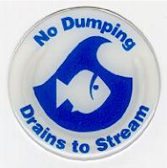
Date: Crew:
Location:
Name of Business:
Area Type: ❑ Residential ❑ Business ❑ Industrial ❑ Park ❑ Parking Lot Type of litter found within 6 feet of storm drain: (check as many as applicable)
- Grass Clippings ❑ Plastic bottles
- Leaves ❑ Glass bottles
- Brush / Branches ❑ Aluminum / Tin Cans
- Cigarette Butts ❑ Newspaper / Magazines
- Clothing / Cloth / Textiles ❑ Plastic bags / wrappers
- Fast food containers: ❑ Caps / Lids to containers
- Six pack holders ❑ Plastic or foam cups / containers
- Motor Oil ❑ Straws
- Paint ❑ Pet Waste
- Other:
Degree of Litter / Pollution: ❑ Minor ❑ Moderate ❑ Severe ❑ Extreme Additional Observations:
/mydocuments/cleancommunities/markerform.doc

