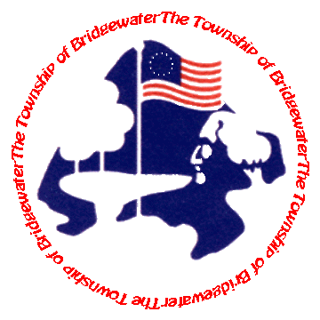
Bridgewater Township Clean Communities
100 Commons Way
Bridgewater, NJ 08807
Phone: 908-725-5750 Fax: 908-595-0825
MONDAY-THURSDAY 9AM to 5PM FRIDAY 8AM to 5PM

“RECYCLING SUPER HERO/ LITTER VILLAIN”
POSTER CONTEST

The Bridgewater Township Environmental Commission and Sustainability Task Force are pleased to announce the “Recycling Super Hero/Litter Villain” poster contest for fourth grade students. Prizes will be awarded for original artwork posters that depict a Recycling Super Hero or a Litter Villain. One Recycling Hero poster and one Litter Villain poster will be selected by a panel of judges at each school. All winning posters from each school represented will be placed on display at the Township Eco-Blast Fair on May 2, 2015. One grand prize winner in each category to be determined by a panel of judges during the fair. The winning posters will be placed on display at the Municipal Complex for the month of May. All entries will be judged on the criteria of creativity and merit. Awards will be provided through a grant from the New Jersey Clean Communities Program.

Submission Guidelines:
- Contest is open to all fourth grade students in the Bridgewater-Raritan School District.
- All participants will receive a certificate of recognition from Bridgewater Township.
- All posters submitted must be no larger than 22 inches by 28 inches in size.
- Posters must be 100% original in concept, design and execution.
- Students must include a name for the Recycling Super Hero or Litter Villain depicted in the poster.
- Students must clearly print their name on the back of the poster and submit a completed entry form at the time of project submission.
- One entry per student only.
- Prizes to include One Recycling Super Hero and One Litter Villain winner from each school ($25 gift card each), One Recycling Super Hero and One Litter Villain Grand Prize Winner ($50 gift card each).

SCHOOL SUBMISSION DUE DATE: April 24, 2015
Name:_______________________________________________________________________________________________
Grade:____________________ | School:_____________________________________________________
Address:_____________________________________________________________________________________________
Phone:_______________________________________________________________________________________________
E-mail:_______________________________________________________________________________________________
I, ______________________________________________, give permission for Bridgewater Township to display my child’s poster, if selected, at the Township Eco-Blast Fair on May 2, 2015.
Signature: of Parent or Guardian___________________________________________________________________
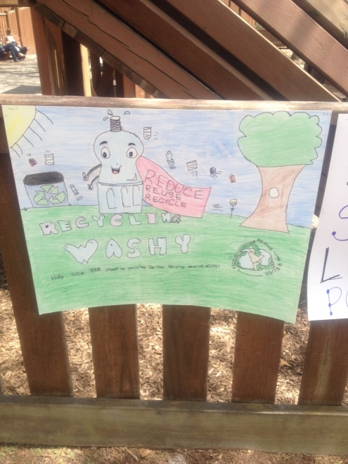
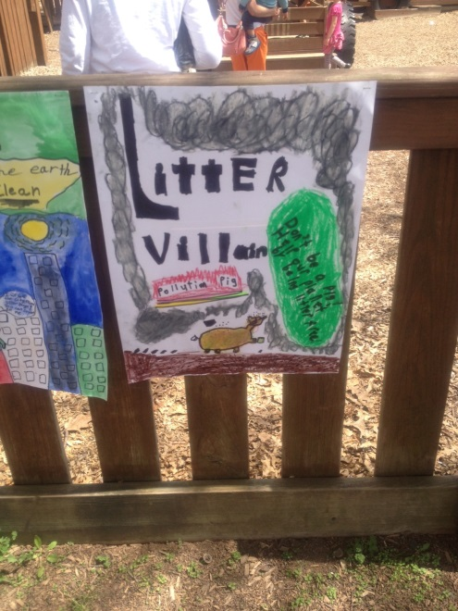
Contest Entries – 2015

