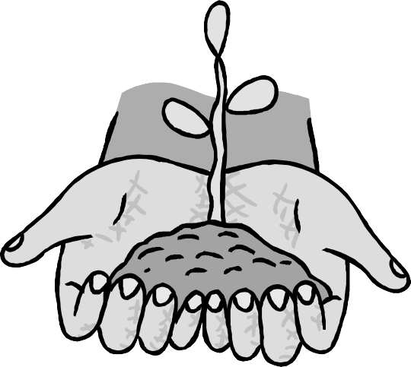

SAFETY GUIDELINES AND RECOMMENDATIONS FOR PARTICIPANTS

Administered by the
Department of Parks and Community Renewal (908)527-4900
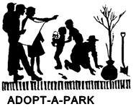

UNION COUNTY
BOARD OF CHOSEN FREEHOLDERS

Angel G. Estrada, Chairman
Alexander Mirabella, Vice Chairman Chester Holmes Deborah P. Scanlon Bette Jane Kowalski Daniel P. Sullivan
Rick Proctor Rayland Van Blake Nancy Ward
George W. Devanney, County Manager
M. Elizabeth Genievich, CMC, MPA, Director Administrative Services
Alfred J. Faella, Director,

Charles Sigmund Jr., Deputy Director, Department of Parks & Community Renewal

Thank you for participating in Union County’s Adopt-A-Park program. Before you begin your project, please take a moment to acquaint yourself with the following safety guidelines and recommendations.

Emergency information
Familiarize yourself with emergency procedures and how to quickly summon the police or an ambulance. A cellular phone on site is recommended.

In case of emergency call the Union County Police at (908)654-9800.

First aid
The leader must have a first aid kit on site. Be sure to inform your group leader of known allergies and physical infirmities prior to participation.

Water breaks
Bring a water supply. Avoid potential problems from over-exertion and heat by drinking water and taking rest breaks.

Clothing
Wear long-sleeved shirts, jeans or long pants, sturdy leather or heavy-soled shoes or boots and gloves.

Youth Participation
Provide appropriate and adequate adult supervision when youth groups are involved in the program.

Avoid unsafe behavior
Climbing trees, horseplay, standing or jumping on guide rails, etc., are considered unsafe behavior and are not allowed at maintenance/clean-up sites.

Recycling
Sort collected debris into two categories:
- Recyclable (glass, aluminum, paper, plastic)
- Non-recyclable (all other material)
It will be easier to sort trash as you pick it up rather than sort it at the final disposal site.
Bring collected trash to disposal and recycling sites as directed by your group coordinator.

Be alert for hazards
- Follow all guidelines when applying paint or other materials.
- Learn to identify poison ivy. The recommended attire will usually prevent irritations from most plants.
- Be alert for bees, wasps and hornets.
- Tuck pant legs into socks, and your shirt into your pants to prevent tick exposure. Check your head and body thoroughly when you return home.
- Pay special attention to the handling of broken glass. Be careful not to step or kneel on broken glass.
- Cancel maintenance or pick-up during extreme weather
conditions.
- Avoid and do not pick up animal carcasses or suspicious materials. Report any waste of this type to your group coordinator.

ALCOHOL IS FORBIDDEN AT ALL MAINTENANCE AND CLEAN-UP SITES.
If for any reason your group coordinator changes, please contact the Department of Parks and Community Renewal with the new coordinator's name and phone number.

You may not participate in a cleanup or maintenance program if you have not signed the waiver form.

Educate your family and friends about Adopt-A-Park and ask them to volunteer by calling (908) 527-4900.

