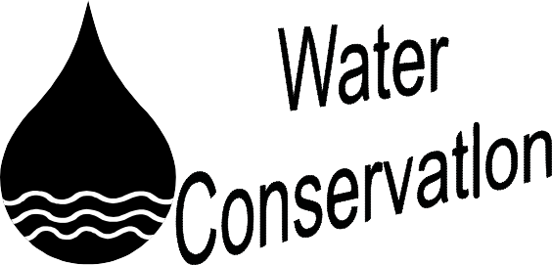Why Save Water ?
Besides saving money, water conserva- tion can help prevent pollution. Using less water reduces run-off and leaves more water in streams or lakes, which protects existing ecosystems such as wetlands and water supplies. Reduced water usage may extend the life of exist- ing sewage treatment plants and can eliminate the need for new water supplies which are expensive to locate and build.

How Much Water Are We Using ?
The average American uses 60 gallons of water a day. That does not include car washing, lawn watering and other out- door uses. Flushing the toilet, bathing and washing clothes are the largest uses of water in the home.

Conservation Measures
Check faucets, hoses, and toilets for leaks. Turn off hoses and connecting faucets when not in use. This will also preserve equipment and avoid leaks. Inspect your water pipes periodically for pinhole leaks and leaks in connections. Repair leaks as soon as possible. Don’t over fill the bathtub. Take shorter showers. Install water saving toilets and shower heads. Don’t let the water run when brushing your teeth or shaving. Keep a bottle of drinking water in the refrigerator so you don’t need to run the tap water for cold water.
Information for this brochure has been pro- vided by the New Jersey Department of Environ- mental Protection, the Passaic River Coalition and the United States Environmental Protection Agency.
Non-point source pollution comes from
many sources. Non-point source pollution is caused by rainfall or snowmelt moving over the ground. As the water moves, it picks up natural and man-made pollutants depositing them into storm drains which lead to our lakes, rivers, wetlands, coastal waters and even our underground sources of drinking water. Some of the pollutants include excess fertilizers, herbicides and insecticides, oil, grease, and toxic chemicals, salt, bacteria from livestock, pet wastes and faulty septic systems.

Some states report that non-point source pollution is the leading cause of water quality problems. The total effects may not always be fully assessed however, we do know that pollutants have harmful effects on our drinking water, recreation, fisheries, and wildlife.

We can all work together and prevent non- point source pollution by changing some everyday habits.

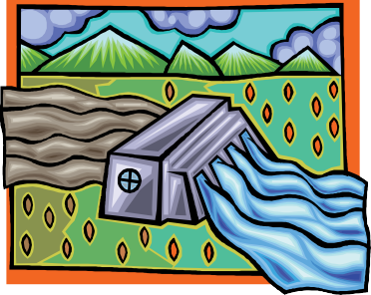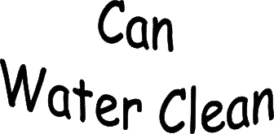Never throw anything down storm drains.

- Don’t Litter.

- Obey Roxbury’s “Pooper Scooper” Law.

- 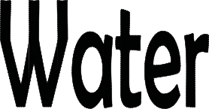Precycle. Buy products with the least amount of packaging avail- able.

- Recycle. Call the Recycling Depart- ment for a list of the required re- cyclables and for further informa- tion.

- Conserve water. Don’t let the wa- ter run when you are brushing your teeth, shorten the length of your showers and repair any leaking faucets.

- 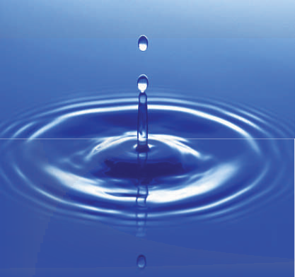Try natural organics instead of fertilizers that contain phosphorus.
Township of Roxbury 1715 Route 46 Ledgewood, New Jersey 07852
973-448-2000

What is Storm Water?
What is a Watershed?
Stormwater Sewers

Stormwater is water from rain and melt- ing snow that flows over lawns, parking lots and streets becoming runoff. This water works its way back into our local waterways and eventually will end up in the Atlantic Ocean. Along with the water, anything such as litter, oil, and/ or fertilizer will also end up in our waterways.

In 2004, the New Jersey Department of Environmental Protection established new stormwater rules that address water quality and the impacts associated with existing and future stormwater discharges. A part of this regulation pertains to new construction and set required components to help protect our water quality. Details of all the new regulations can be found in the Department of Environmental Storm Water Management Rules. The website for the NJDEP is www.nj.gov/dep/ watershedmgt/stormwater.
A watershed is the area of land that drains into a body of water such as our local streams, rivers and lakes. It is sepa- rated from other systems by high points in the area such as hills or slopes. It includes not only the waterway but also the land area that drains into it.

Complications from our actions can affect our watersheds. Changing the way storm water flows, littering, oil or other vehicle fluids from parking lots, using too much fertilizer or fertilizer containing phospho- rus can critically affect a watershed. It is important to practice pollution preven- tion to help eliminate the damage being done to our watershed.

What is Ground Water
It is very simple, if rainwater soaks into the ground, it is ground water. Ground water moves into water-filled layers of porous geologic formations called aquifers. Aquifers are not flowing underground streams or lakes. Aquifers can range from a few feet below the surface to several hundred feet underground. A system of more than 100 aquifers is scattered throughout New Jersey covering 7,500 square miles.

Ground water is the primary drinking water source for half of New Jersey’s population. Most of the water is obtained from individual domestic water or public water supplies which tap into aquifers.
Stormwater flows into the system through a storm drain. These are located along the curb line of roadways and parking lots. The grate that prevents larger objects from flowing into the storm drain is called a catch basin. Once water is in the drain, it flows through pipes to local streams, rivers and lakes. In most areas of New Jersey, the stormwater goes directly to our local waterways without any treatment.

Much of the debris and other pollutants such as salt that have settled on the surface and in the stormwater sewer are picked up and carried to the local waterways during a rainstorm. This adds to the water quality problems and it is important to protect the stormwater system from this debris.

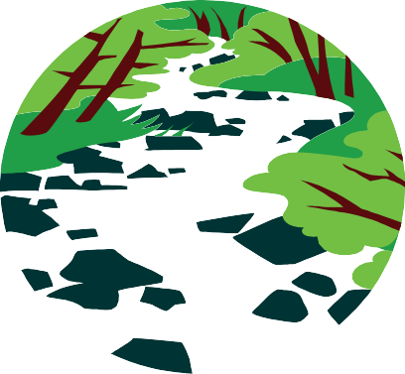The following should NEVER be dumped down storm drains. Motor oil, pet waste, grass trimmings, leaves, hazardous chemicals or any other type of debris. Storm drains are made for water only.

Storm Drain Labeling

Soon you will begin seeing labels on the storm drains in your area. The new storm drain labeling requirements from the New Jersey Department of Environmental Protection’s municipal stormwater permitting program requires the Township to label all of our storm drains to make people more aware of non-point source pollution, polluted run-off and the connection between the storm drains and our local waterways.

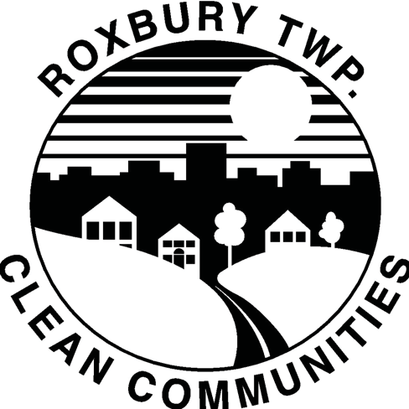The storm drain labeling program in Roxbury will be run in conjunction with th e Cl ea n
Commun i ties Program. The
Roxbury Clean Commun i ties program pro-
motes litter abatement and awareness, along with sponsoring
local clean ups, educational programs for our schools and other functions.

