olutions to
S
Stormwater Pollution

Easy Things You Can Do Every Day To Protect Our Water

A Guide to Healthy Habits for Cleaner Water

ollution on streets, parking lots and lawns is washed by rain into storm drains, then directly to our drinking water supplies and the ocean
P
and lakes our children play in. Fertilizer, oil, pesticides, detergents, pet waste, grass clippings: You name it and it ends up in our water.

Stormwater pollution is one of New Jersey’s greatest threats to clean and plentiful water, and that’s why we’re all doing something about it.

By sharing the responsibility and making small, easy changes in our daily lives, we can keep common pollutants out of stormwater. It all adds up to cleaner water, and it saves the high cost of cleaning up once it’s dirty.

As part of New Jersey’s initiative to keep our water clean and plentiful and to meet federal requirements, many municipalities and other public agencies including colleges and military bases
must adopt ordinances or other rules prohibiting various activities that contribute to stormwater pollution. Breaking these rules can result in fines or other penalties.

As a resident, business, or other member of the New Jersey community, it is important to know these easy things you can do every day to protect our water.

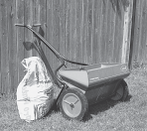Limit your use of fertilizers and pesticides

- Do a soil test to see if you need a fertilizer.
- Do not apply fertilizers if heavy rain is predicted.
- Look into alternatives for pesticides.
- Maintain a small lawn and keep the rest of your property or yard in a natural state with trees and other native vegetation that requires little or no fertilizer.
- If you use fertilizers and pesticides, follow the instructions on the label on how to correctly apply it.

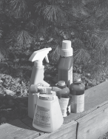

Make sure you properly store or discard any unused portions.

Properly use and dispose of hazardous products

- Hazardous products include some household or commercial cleaning products, lawn and garden care products, motor oil, antifreeze, and paints.
- Do not pour any hazardous products down a storm drain because storm drains are usually connected to local
waterbodies and the water is not treated.

  - If you have hazardous products in your home or workplace, make sure you store or dispose of them properly. Read the label for guidance.
  - Use natural or less toxic alternatives when possible.
  - Recycle used motor oil.
  - 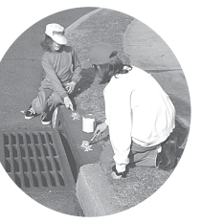Contact your municipality, county or facility management office for the locations of hazardous-waste disposal facilities.

Keep pollution out of storm drains

  - Municipalities and many other public agencies are required to mark certain storm drain inlets with messages reminding people that storm drains are connected to local waterbodies.

Clean up after your pet

- Many municipalities and public agencies must enact and enforce local pet-waste rules.
- An example is requiring pet owners or their keepers to pick up and properly dispose of pet waste dropped on public or other people’s property.
- Make sure you know your town’s or agency’s requirements and comply with them. It’s the law. And remember to:
  - Use newspaper, bags or pooper-scoopers to pick up wastes.
  - Dispose of the wrapped pet waste in the trash or un- wrapped in a toilet.
  - Never discard pet waste in a storm drain.

Don’t feed wildlife

- Do not feed wildlife, such as ducks and geese, in public areas.
- Many municipalities and other public agencies must enact and enforce a rule that prohibits wildlife feeding in these areas.

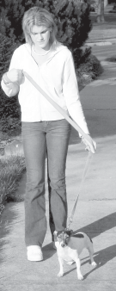

Don’t litter

- Place litter in trash receptacles.
- Recycle. Recycle. Recycle.
- Participate in community cleanups.
Contact information
For more information on stormwater related topics, visit www.njstormwater.org or www.nonpointsource.org

Additional information is also available at U. S. Environmental Protection Agency Web sites www.epa.gov/npdes/stormwater or www.epa.gov/nps

New Jersey Department of Environmental Protection Division of Water Quality
Bureau of Nonpoint Pollution Control Municipal Stormwater Regulation Program (609) 633-7021

Dispose of yard waste properly

- Keep leaves and grass out of storm drains.
- If your municipality or agency has yard waste collection rules, follow them.
- Use leaves and grass clippings as a resource for compost.
- 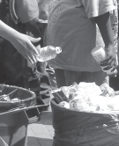Use a mulching mower that recycles grass clippings into the lawn.

  - Do not let sewage or other wastes flow into a stormwater system.

www.cleanwaternj.org

