BOAT DISCHARGES
Dumping boat sewage over- board introduces bacteria and viruses into the water. Boat owners should always use marine sanitation devices and pump-out facilities at marinas.

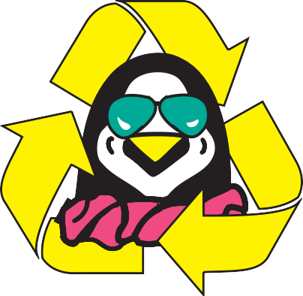

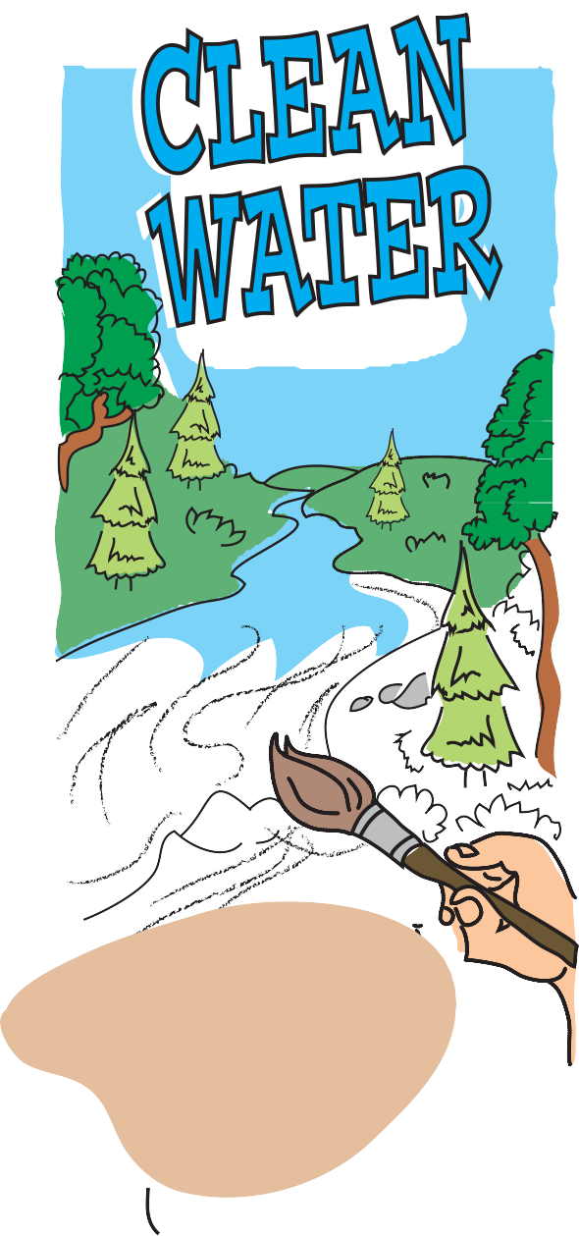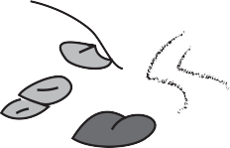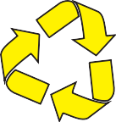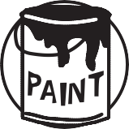SOMERSET COUNTY DIVISION OF SOLID WASTE
HOUSEHOLD HAZARDOUS PRODUCTS
Many common household products (paint thinners, moth balls, drain and oven cleaners, to name a few) contain toxic ingredients. When improperly used or discarded, these products are a threat to public health and the environment. Do not discard with the regular household trash. Use natural and less toxic alternatives whenever possible. Contact the Somer- set County Solid Waste Management Office for information regarding house- hold hazardous waste collections, call 908-231-7031 for a printed list of household cleaning alternatives.
20 GROVE STREET SOMERVILLE, NJ 08876
Phone: (908) 231-7031 • Fax: (908-707-1749
www.co.somerset.nj.us
YARD WASTE
Compost yard waste (leaves, grass, etc.). Don’t blow waste into the street or storm drains.

Sponsored by the Somerset County Board of

Chosen Freeholders

Just being concerned about the environment is not enough; now you can help improve it. Choose to protect our water resources TODAY.

What is Non-point Source Pollution?

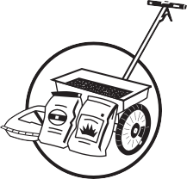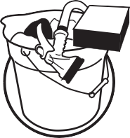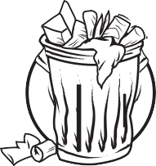Nonpoint Source Pollution, or people pollu- tion, is a contamination of our ground water, waterways, and ocean that results from every- day activities such as fertilizing the lawn, walk- ing pets, changing motor oil and littering. With each rainfall, pollutants generated by these activities are washed into storm drains that flow into our waterways and ocean. They also can soak into the ground contaminating the ground water below.
FERTILIZER & PESTICIDES
Fertilizers contain nitrates and phosphates that, in abundance, cause blooms of algae that can lead to fish kills. Avoid the overuse of fertilizers and do not apply them before a heavy rainfall.
PESTICIDES: Many household products made to exterminate pests also are toxic to humans, animals, aquatic organisms and plants. Use alternatives whenever possible. If you do use a pesticide, follow the label directions carefully.
PET WASTE
Animal wastes contain bacte- ria and viruses that can contaminate shellfish and cause the closing of bath- ing beaches. Pet owners should use newspaper, bags or scoopers to pick up after pets and dispose of wastes in the garbage or toilet.
CAR WASHING SOAP
Wash your car only when necessary. Consider using a commercial car wash that recycles its wash water. Like fertilizers, many car detergents contain phosphate. If you wash your car at home, use a non-phosphate deter- gent.
LITTER
Place litter, including cigarette butts and fast food containers, in trash receptacles. Never throw litter in streets or down storm drains. Recycle as much as possible.

Each one of us, whether we know it or not, contributes to nonpoint source pollution through our daily activities. As a result, non- point source pollution is the BIGGEST threat to many of our ponds, creeks, lakes, wells, streams, rivers and bays, our ground water and the ocean.

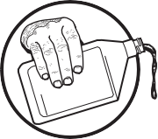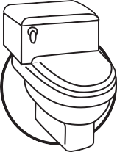The collective impact of nonpoint source pollution threatens aquatic and marine life, recreational water activities, the fishing indus- try, tourism and our precious drinking water resources. Ultimately, the cost becomes the burden of every New Jersey resident.
MOTOR OIL
Used motor oil contains toxic chemicals that are harmful to animals, humans and fish. Do not dump used motor oil down storm drains or on the ground. Recycle all used motor oil by taking it to a local public or private recy- cling center.
SEPTIC SYSTEMS

An improperly working septic system can contaminate ground water and create public health problems. Avoid adding unnecessary grease, household hazardous products and solids to your septic system. Inspect your tank annually and pump it out every three to five years depending on its use.

But there's good news - in our everyday activi- ties we can stop nonpoint source pollution and keep our environment clean. Simple changes in YOUR daily lifestyle can make a tremendous difference in the quality of New Jersey's water resources. Here are just a few ways you can reduce nonpoint source pollu- tion.

