Bergen County has included an anti-litter message in their Zika prevention campaign.
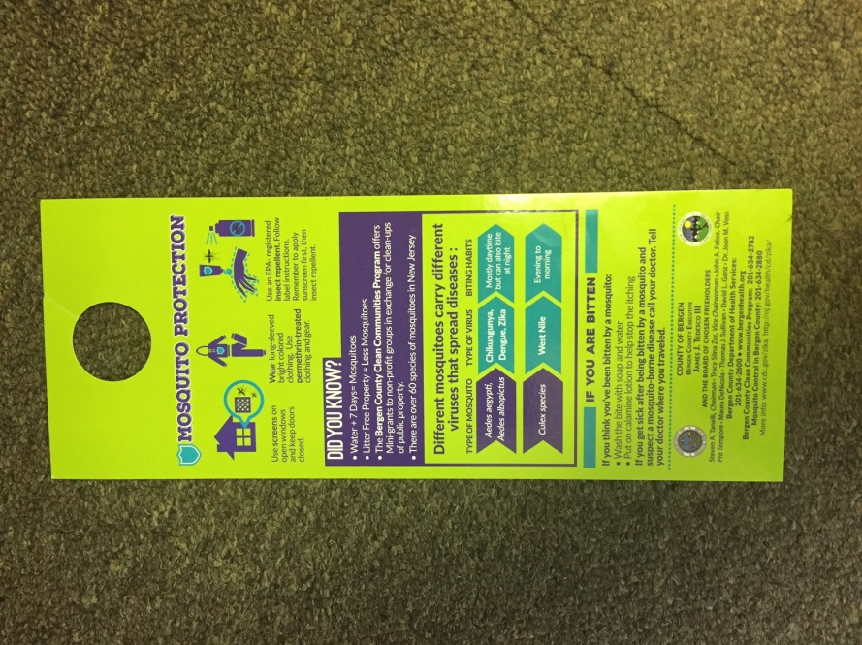
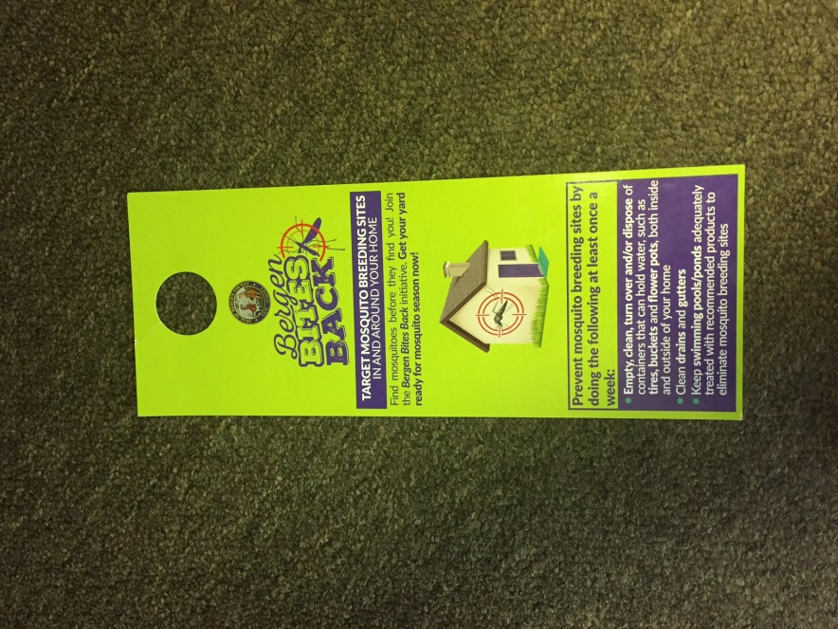
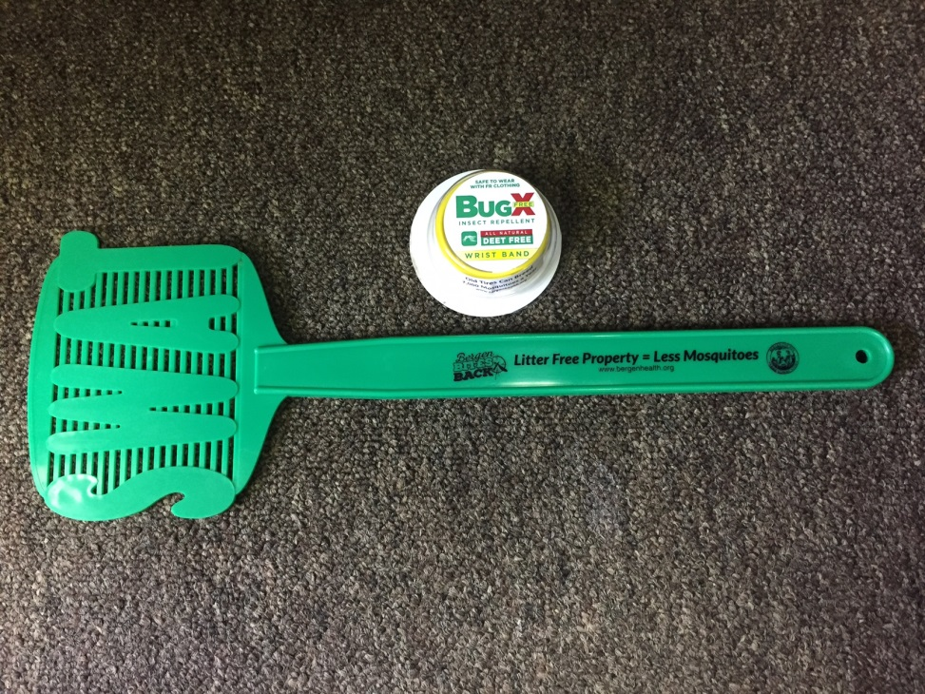
See their website at http://www.co.bergen.nj.us/index.aspx?NID=1418 for more information.

