PHILOSOPHY

The cleaner a property is, the less likely people are to litter so please consider the following suggestions for a
litter-free work environment

BEST PRACTICES FOR BUSINESSES

- Place adequate number of receptacles (garbage & recycling) in parking lots as well as inside and outside all building entrances. Use covered trash containers to eliminate trash from spilling or blowing out.
- Establish a regular schedule for emptying trash and recycling containers rather than emptying them on an ‘as needed’ basis.
- Establish smoking areas with appropriate cigarette butt receptacles for employees and customers.
- Remember to locate recycling and trash containers next to each other; label them with proper wording and pictures.
- Ensure roll-offs have adequate storage for quantity of waste generated between pickups.
- Educate employees, especially maintenance staff, that litter is not acceptable and should be picked up.
- Have employees conduct a Litter Cleanup Program in and around the property and post pictures in company newsletter or on website. Don’t forget trapped litter around fence lines.
- Prohibit dissemination of fliers on windshields.
- Provide receptacles at drive up windows before window, in shopping cart areas and parking lots.
- Don’t forget to prevent litter from fleet vehicles too:
  - Require tarps on any vehicles transporting materials
  - Instruct drivers to pick up materials that have fallen off their load
  - Add litter bags to all company vehicles
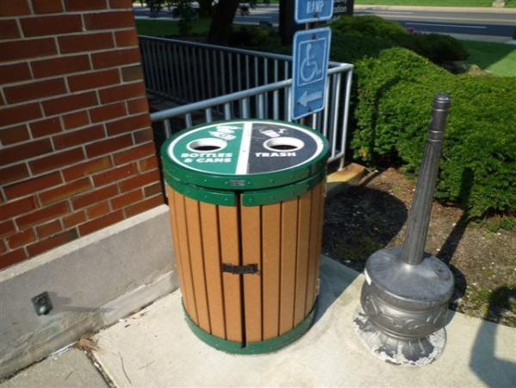
DO’s

COMPANIES DOING IT RIGHT!!

Covanta’s Annual Cleanup in Newark
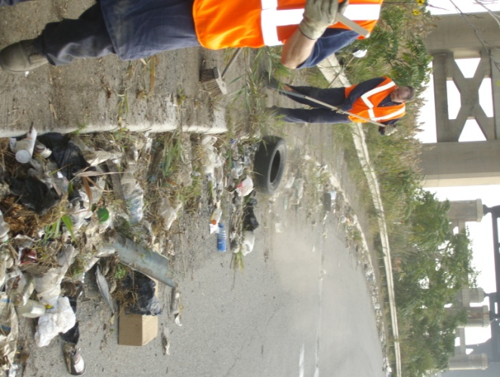
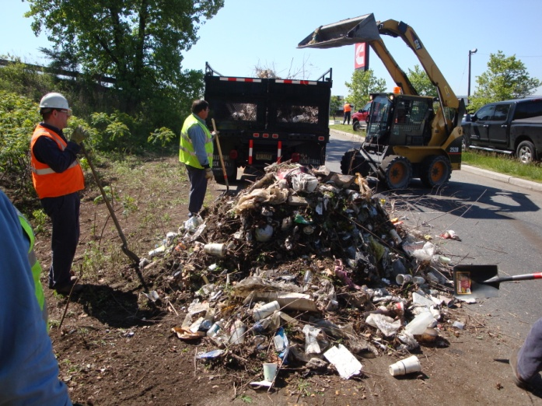

Waste Management
WM’s Annual Cleanup
in Elizabeth

NY Yankees!
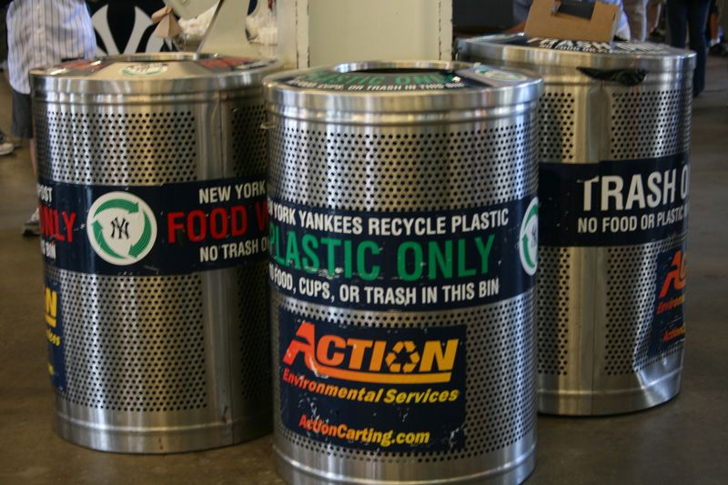

DONT’s…………
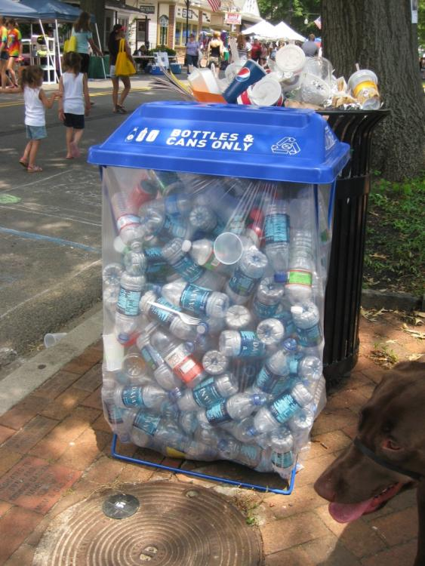
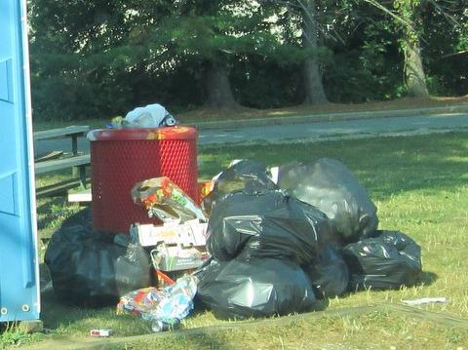
Provide adequate number of receptacles (garbage & recycling)

Empty trash and recycling containers regularly!

