Plastic Straws
Plastic Straws are one of the items most commonly found during beach cleanups. A few local and national organizations are starting a movement to ask people to not take straws and to have restaurants only give out straws when requested. Click on the links below for more ideas!

https://www.skiptheplasticstraw.com/
Website by Seventh Grade student to campaign against the use of single-use plastic straws

https://southjersey.surfrider.org/programs/rise-above-plastics/plastic-straws-suck/
South Jersey Surfrider foundation

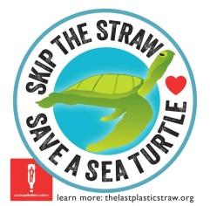
http://www.plasticpollutioncoalition.org/no-straw-please
Plastic Pollution Coalition

https://www.lonelywhale.org/strawless-ocean/
Lonely Whale Foundation

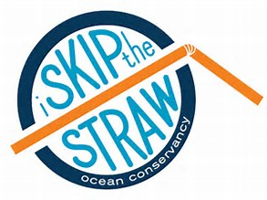
https://oceanconservancy.org/blog/2016/11/28/preventing-marine-debris-one-straw-at-a-time/
Ocean Conservancy

https://www.cleanwateraction.org/2017/05/24/just-say-no-straws
Clean Water Action
