NJDEP Hotline: 1-887-927-6337
Morris County Hotline: 1-888-260-3802 Morris County Department of Law & Public Safety

Illegal Dumping Enforcement:

Illegal dumping and other harmful unau- thorized activity will result in swift and severe enforcement penalties including:

N.J.S.A. 13:1D-9.3
- A fine of $2,500 for the first offense; up to $5,000 for the second; and up to
$10,000 for each subsequent offense.
- Loss of driver’s license for six months to one year.
- Forfeiture of vehicles used or intended for use in the unlawful transportation or disposal of solid waste.
- Community service up to 90 days.

N.J.A.C. 7:26-3.4 (b)
- Failure to deposit all collected solid waste at an approved facility. Base penalty
$5,000.00 - Non Minor Violation.

PUBLIC HEALTH
Prevent, Promote, Protect

Morris County Department of Law
& Public Safety Office of Health Management
PO Box 900
Morristown, NJ 07963-0900 located at 634 West Hanover Ave.
Morris Township, NJ 07961 Phone 973-631-5484, Fax 973-285-6905

Morris County Solid Waste Enforcement
Phone 973-347-1106, Fax 973-347-3784

Contact your local Police Department Contact your local Health Department

N.J.D.E.P. Hotline:
1- 887- WARN DEP (1-887-927-6337)

Illegally dumped mattress and debris in the woods.

Morris County Solid Waste Enforcement Hotline:
1-888-260-3802
www.morriscountynj.gov/health/

N.J.D.E.P. Hotline:
1- 887- WARN DEP (1-887-927-6337)

Printed August 2015

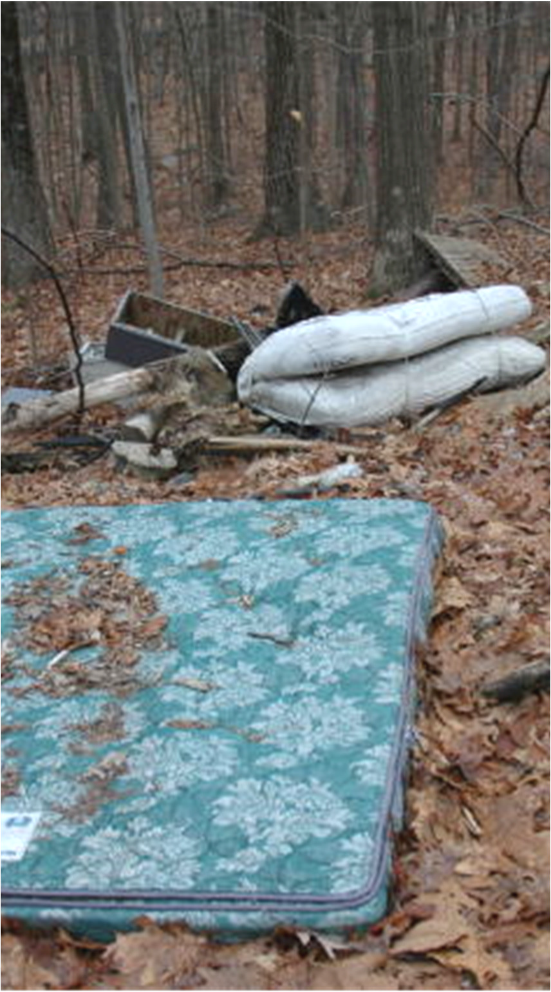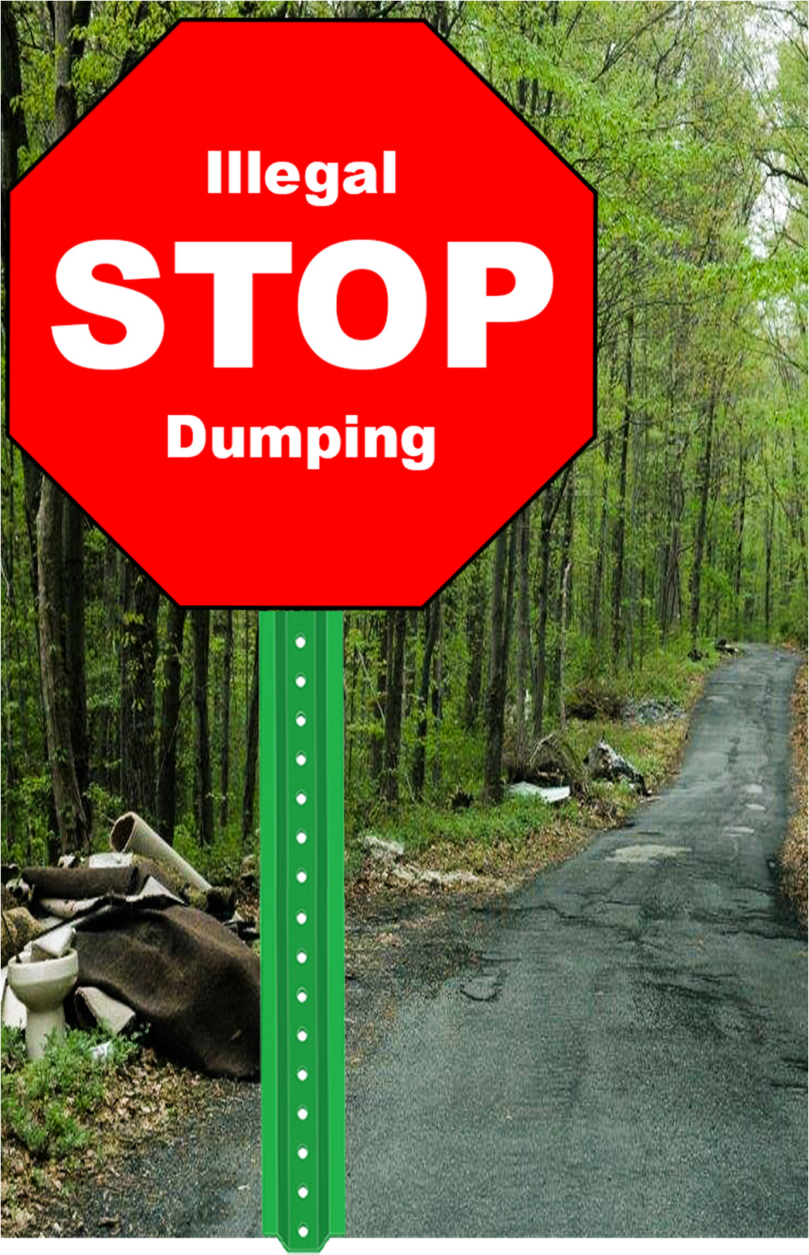
web: http://www.morrishumanservices.org/health
www.morriscountynj.gov/health/
Office of Health Management

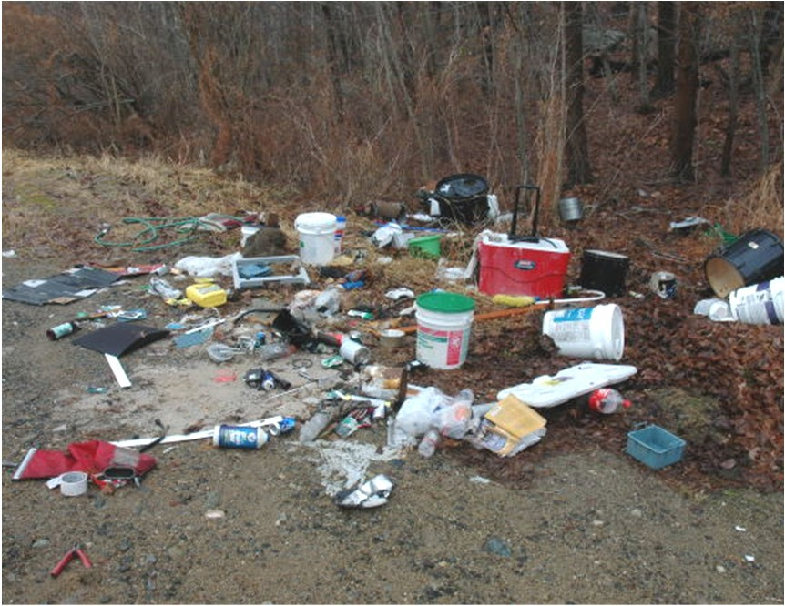
Construction contractor’s garbage illegally dumped in a state park.

What is illegal dumping?
Illegal dumping is the intentional dumping of solid waste on public or private property not permitted to receive the waste without the property owner’s consent. It is also referred to as “open dumping,” “fly dumping,” or “midnight dumping.” Illegal dumping also includes throwing debris out of a car window, placing waste along roadsides or in someone else’s dumpster.

Illegal dumping typically includes:
- Construction and demolition debris, such as drywall, roofing shingles, lumber, bricks, concrete, asphalt millings, and siding.
- Appliances or “white goods”
- Furniture
- Yard waste/landscaper waste
- Household waste
- Medical waste
- Fast food litter and cigarette butts

Who illegally dumps?
- Contractors
- Landscapers
- Tire recyclers
- Small waste hauling contractors
- Local residents
- Ignorant people

Illegal dumping occurs for a variety of reasons:
- Save money to avoid disposal fees and transportation costs.
- Lax enforcement.
- Laziness or not being aware of where to dispose of the waste.
- Materials banned from landfills.
- Avoid state solid & hazardous waste regis- tration regulations.

Illegal dumping sites:
Illegal dumping sites may vary but often include abandoned residential, commercial, or industrial properties, private or public land (state parks), railways, and infrequently used roadways.
Dumpers look for areas that are rarely main- tained and vulnerable because of their accessi- bility and poor lighting. Illegal dumping common- ly occurs at night or in the early morning hours.

Why is illegal dumping a problem?
The health risk associated with illegal dumping is significant. Areas used for illegal dumping may be accessible to people, especially children, who are vulnerable to the physical (protruding nails or sharp edges) and chemicals (harmful fluids or dust) hazards posed by wastes. Rodents, insects and other vermin attracted to dump sites may also pose a health risk. Dump sites with scrap tires provide an ideal breeding ground for mos- quitos.

In addition, countless neighborhoods have been evacuated and property damage has been signif- icant because of dump sites that caught fire, either by spontaneous combustion or, more com- monly, by arson.

Illegal dumping can impact proper drainage or runoff, making areas more susceptible to flooding when wastes block ravines, creeks, culverts, and drainage basins.

How can I help?
Morris County’s Solid Waste Enforcement Office is dedicated to investigating and resolving citizen reports of illegal dumping. While not every com- plaint can be resolved quickly, be assured we are committed to investigating promptly and taking appropriate action. You may remain anonymous.

Report the illegal dumping or suspicious behavior to the Police Department, but do not approach illegal dumpers. Report:

- Date and time of the incident.
- The vehicle license plate.
- A description of the vehicle.
- The location of the dumping incident.

Spread the word to your friends and neighbors that illegal dumping is a crime.

SEE IT, REPORT IT!

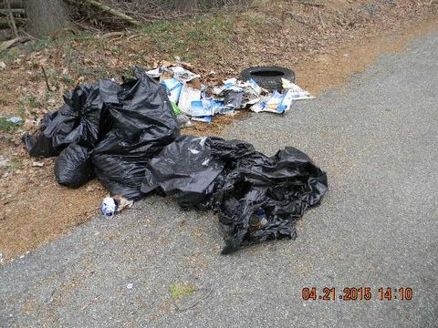

Household garbage dumped illegally on the side of a road.
This pamphlet and the information contained herein shall not constitute legal advice and should not be relied upon in lieu of consultation with the appropriate legal advisors. In addition, the contents of this pamphlet are not intended to supersede, abridge or alter the regulations set forth by the New Jersey Department of Environmental Protection (NJDEP).

