New Jersey Towns Ban Releasing of Balloons

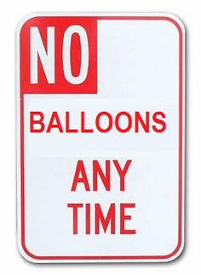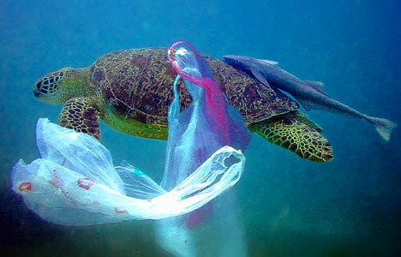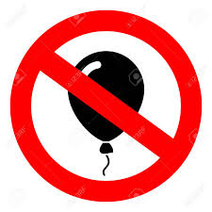

As of January 2019 there are about 20 towns that have banned the release of balloons:

Asbury Park Margate
Atlantic City New Milford
Avalon North Wildwood
Bradley Beach Point Pleasant Beach
Brigantine Sea Isle City
Cape May City Somers Point
Egg Harbor Stone Harbor
Lavalette Tinton Falls
Long beach Township Upper Township
Longport Ventor

Sample of Municipal Balloon Release Ban Ordinances
ATLANTIC CITY | https://ecode360.com/print/AT0848?guid=32079854&children=true
LONGPORT | https://ecode360.com/print/LO0700?guid=10307679&children=true
NEW MILFORD | http://www.newmilfordboro.com/home/180013952/180013952/Images/2017-19%20Intentional%20Release%20of%20Balloons.pdf
NORTH WILDWOOD | https://ecode360.com/8053367
SEA ISLE CITY | http://www.sea-isle-city.nj.us/LinkClick.aspx?fileticket=iSzCJt-oq3w%3D&tabid=2415&mid=7733

THINGS TO KNOW:
- There are only 5 States that passed the Ban on Balloon Release: California, Connecticut, Florida, Tennessee, and Virginia.
- New Milford in Bergen County is the only North Jersey town that has passed such law.
- Fines range from no less than $100 up to no more than $500.
- The exception to this law is only a person on behalf of a governmental agency or pursuant to a governmental approved contract used for meteorological or scientific purposes. The other exceptions are hot air balloons that are recovered after being launched and balloons that are released indoors.
- The Sea Turtle Foundation estimates that 100,000 marine mammals and turtles and 1 million sea birds die every year from ingesting or becoming entangled in balloon debris.
- There is evidence to suggest that micro-plastics are becoming so tiny that even oysters are able to consume them.
- A balloon that is released into the atmosphere is considered to be airborne litter.
- Metallic coating on Mylar Balloons can cause power outages and or fire when the balloon comes in contact with the electrical lines.
- Under right conditions it would take many years for latex balloons to biodegrade.

The three links below are extreme graphic cases on why we should not release balloons in to the atmosphere:

- https://www.fws.gov/news/blog/images/open-spaces-blog/815balloon3.jpg
- https://www.fws.gov/news/blog/images/open-spaces-blog/815balloon2.jpg
- http://balloonsblow.org/photo-gallery/

