Prize Wheel

The clicking sound of a prize wheel is the perfect hook to capture your audience. It takes us back to fun times spent on the boardwalk, filled with the anticipation and excitement of winning.

The prize wheel is a wonderful educational tool when you place litter-related questions in its twelve, pie-shaped segments. It is great to use at events, such as Earth Day and 4-H fairs because people hear the sound and are curious to find out what is going on. In addition, it is works well when speaking to students at schools or groups, such as Boy Scouts and environmental clubs. You can make up as many questions as you like and change the wheel to meet the needs of your audience or subject matter. The wheel comes with a CD that provides a template which is the correct size and shape for the segments of the wheel.

This is a nice way of making your audience focus on specific topics. If you provide a give-away, like a pen or pencil, (made of recycled content) they seem to appreciate it more when they have to “work” for the prize!

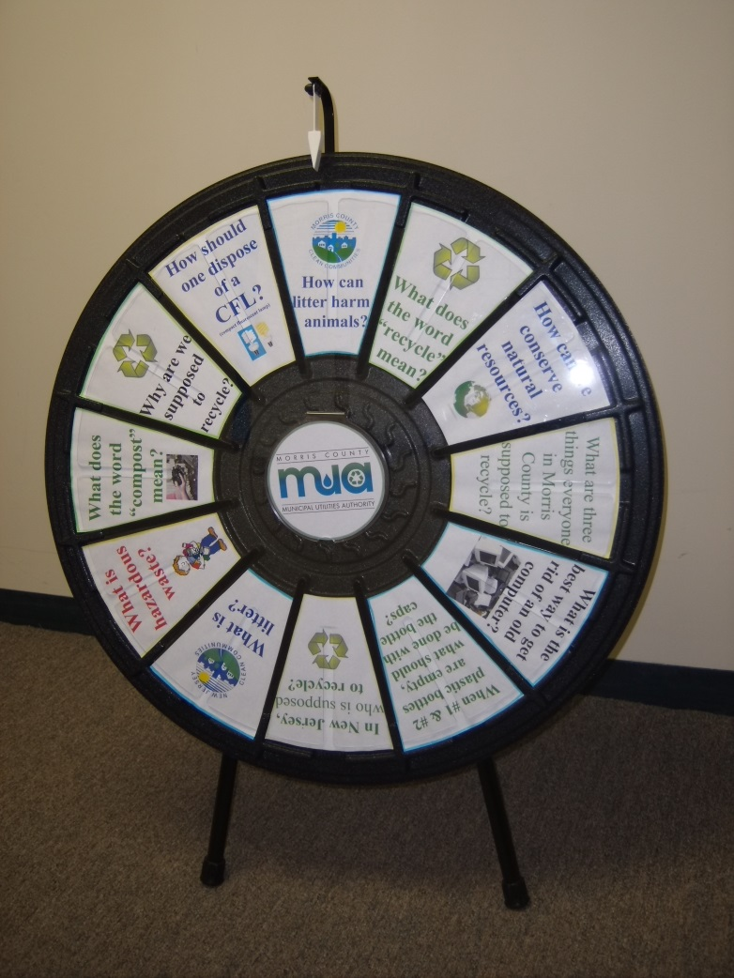

The prize wheel pictured was purchased from:
www.PrizeWheel.com
1-800-523-5542

