Clean Communities
The activity book has been produced to educate youth about the harmful effects of litter on wildlife and the environment. Please do your part to make your community cleaner. Our mission is to reduce litter through education. Clean Communities are safe, healthy, sustainable communities.
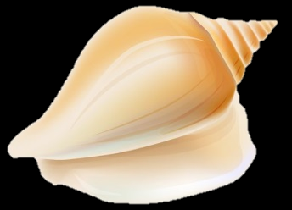
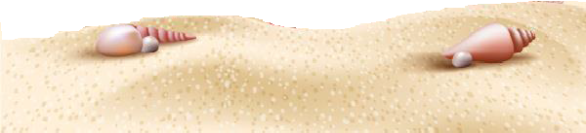
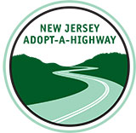
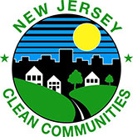
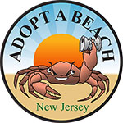
The NJ Clean Communities Council not only provides grants to towns and counties to help fight litter but also administers the Adopt-a-Beach and Adopt-a-Highway programs.

