Button Maker
Make buttons and magnets for or at your next event! The button/magnet maker is:
- Easy to Use
- Portable
- Interactive
- Provides an infinite amount of uses/graphics

There are optional sizes (round, oval, square and rectangle). Union County purchased the 2” x 2” Square as we felt it was ideal for both buttons AND magnets (also has a keychain option). You need to purchase a button machine, graphic punch and supplies (button packs/magnet backs).

See below for button ideas

Button Biz
P.O. Box 31516
Omaha, NE 68131
www.buttonbiz.com

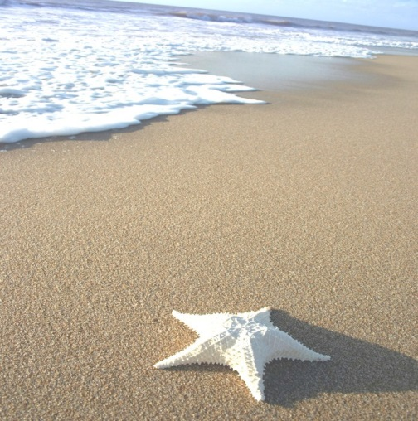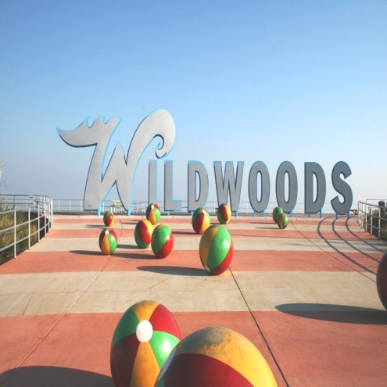
Keep Union County
Parks Clean
Clean Communities
Kids Day 2012
Clean Communities
Kids Day 2012

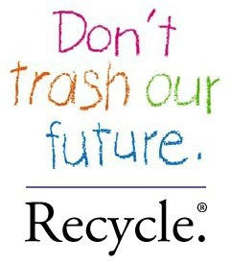
Its Easy Being Green In Union County
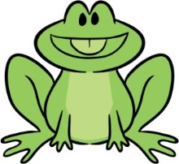
REDUCE, REUSE, RECYCLE
Recycling Hotline: 908-654-9889

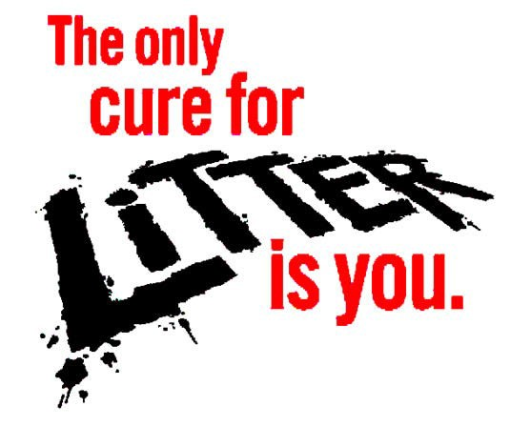

PLEASE KEEP
UNION COUNTY PARKS CLEAN

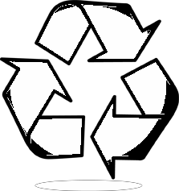
Make Earth Day Every Day in Union County
Help Union County
REDUCE, REUSE,
RECYCLE
Recycling Hotline: 908-654-9889

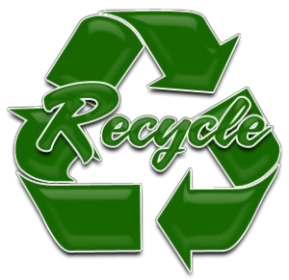
www.ucnj.org/recycle

Make Earth Day Every Day
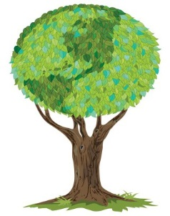
in Union County

www.ucnj.org/recycle

Please Keep Union County Parks Clean & Litter Free

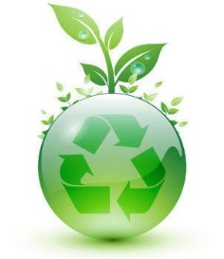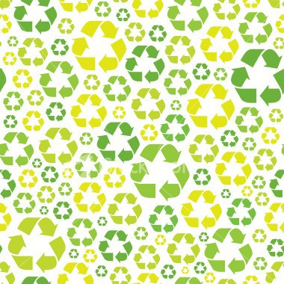
Make Earth Day Every Day
in Union County

www.ucnj.org/recycle
MAKE EVERY DAY EARTH DAY
RECYCLE!!
www.ucnj.org/recycling

