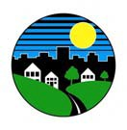South Brunswick Township Clean Communities Program
P.O. Box 190 Monmouth Junction, NJ 08852

Printed on recycled and recyclable paper, of course!

Celebrate EARTH DAY 2006

YOU have the power to make a BIG difference!

Here’s how:
- Choose any littered area to clean up between April 1 and April 30.

- Call the Public Works Department at (732)329-4000, extension 7274 with details on where and when you expect to clean up. Bags and gloves will
be supplied.

- Do the actual cleanup.

- Join the celebration on Sunday, April 23 from 12 NOON to 2PM at Reichler Park.
(In case of rain the event will be held at the South Brunswick Senior Center).

Individuals and Groups Welcome!

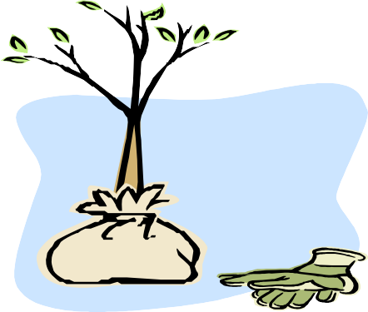A commemorative tree planting ceremony will kick off the
afternoon’s events.

FREE T Shirts (while they last)
FREE hot dog, soda, tree seedling,
DJ, and games for volunteer workers.

