Earth Day 2008 Care Globally, Clean Locally!

Participation is easy, fun and REALLY makes a
difference. Just follow these steps:

Choose any littered area to clean up between April 1 and April 27
- Call the Public Works Department at (732) 329-4000, extension 7274, with details on where and when you expect to clean up. Bags and gloves will be supplied.
- Do the actual cleanup.
- Join the celebration on Sunday,April 27 from 12 noon to 2PM at Reichler Park.
(In case of rain the event will be held at the South Brunswick Senior Center).

Special programs available for schools.

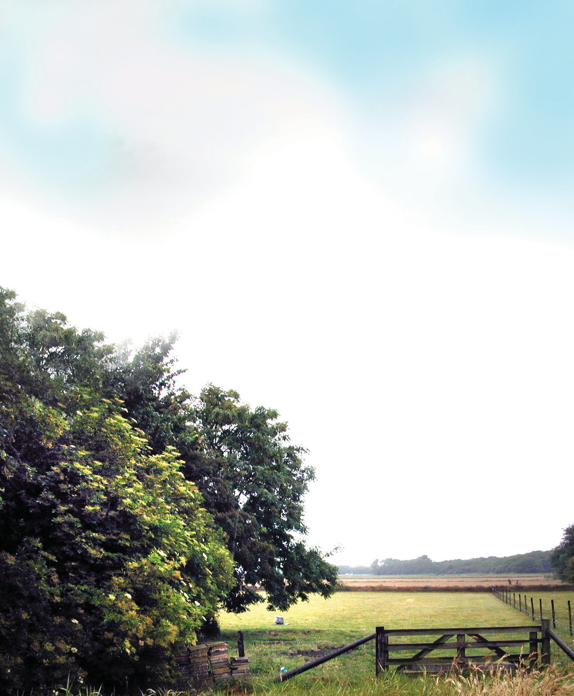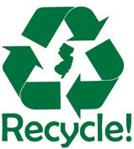
Printed on recycled and recyclable paper, of course!

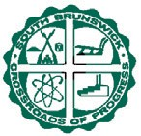South Brunswick Township, Clean Communitites Program, P.O. Box 190, Monmouth Junction, NJ 08852

Celebrate Earth Day by helping to clean up South Brunswick Township and then join the
celebration on April 27

South Brunswick Township Clean Communitites Program
  - Box 190
Monmouth Junction, NJ 08852

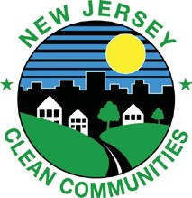

Some simple things YOU can do to celebrate Earth Day:

    - 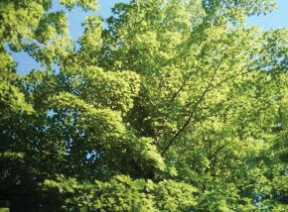Turn off lights,TV or stereo when you leave a room.
    - Walk, ride your bike or carpool.
    - Turn off water while brushing your teeth.
    - Don’t throw oil, pet waste or other things down the storm drain.
    - Don’t use the toilet as a wastebasket.
    - Use a hose gun.
    - Cut and leave your grass clippings and use less water and fertilizer because of it.
    - Use both sides of the paper.
- Cut up plastic 6-pack rings.
- Use reusable lunch bags and sandwich containers.Avoid disposables.
- Don’t litter and pick up litter you see.
- Recycle and buy recycled products.
- Give old clothes or toys to a relative or neighbor, have a garage sale or donate the items.
- Compost.
- Use rechargeable batteries.

