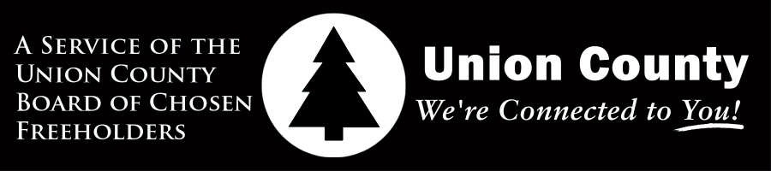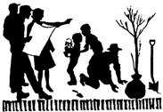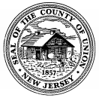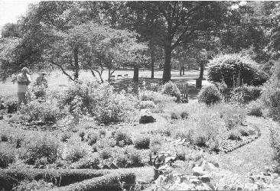

ADOPT-A-PARK

UNION COUNTY
BOARD OF CHOSEN FREEHOLDERS

Angel G. Estrada, Chairman
Alexander Mirabella, Vice Chairman Chester Holmes Deborah P. Scanlon Bette Jane Kowalski Daniel P. Sullivan
Rick Proctor Rayland Van Blake Nancy Ward
George W. Devanney, County Manager
M. Elizabeth Genievich, CMC, MPA, Deputy County Manager/
Director Administrative Services
Nicole L. DiRado, RMC, MPA, Clerk of the Board
Alfred J. Faella, Director, Department of Parks & Community Renewal
Charles Sigmund Jr., Deputy Director, Department of Parks & Community Renewal
Union County’s

Administered by the
Department of Parks and Community Renewal (908) 527-4900
www.ucnj.org

WHAT IS ADOPT A PARK?
Union County is a rich and diverse region that boast 35 parks spanning over 6,600 acres. The Adopt-A-Park program encourages the public to become a part of the County’s continued commitment to excellence by helping to maintain and care for green space in your community. It is designed to foster volunteer stewardship of the County's parkland through "adoption" of a particular park, picnic area, ball field, trail or flowerbed. Specific maintenance projects and clean-ups are assigned depending on the volunteer group’s expertise and desire.

WHY SHOULD I VOLUNTEER?
Volunteering for the Adopt-A-Park program will:
- Give you a sense of pride and ownership in your com- munity
- Make a visible difference in your neighborhood
- Provide a feeling of accomplishment
- Enable you to make a difference in the environment

WHO CAN ADOPT A PARK?
Scouts, religious groups, youth groups, families, civic groups and environmental clubs are just a few examples of those who may participate, but any group, organization, or business may adopt a park.

WHAT KINDS OF ACTIVITIES ARE THERE?
Volunteers assume responsibility for a whole range of activities: weeding, planting flowers, painting, picking up litter, spring cleanup, and trail maintenance to name a few.

DO I NEED ANY SPECIAL SKILLS?
Not at all! We match up your interests and abilities with available projects. What's more, we supply you with support, tools, materials and instruction.
HOW DO I ADOPT A PARK?
You and your group can adopt a park by calling the Department of Parks and Community Renewal at (908)527-4900. The Adopt-A-Park coordinator will assist you in selecting an area or you may express a preference.

WHAT DOES IT MEAN TO ADOPT A PARK ?

GROUP RESPONSIBILITIES
When you adopt a park, your group may decide to work on a specific maintenance project or you may do general cleaning and maintenance. The length of time may depend on the project. You are encouraged to maintain a clean site throughout the year and visit the park on occasion to determine if additional clean-ups are necessary.

SELECT A GROUP LEADER
Your group will identify a leader at the time you adopt a park. That person will act as liaison between the County's Adopt-A-Park coordinator and your volunteers. He or she will be responsible for distributing information to your group prior to park cleanup days, and seeing that the safety guidelines and recommendations set by the County of Union are followed.
County coordinators may visit park sites on the day of your project, but your group is solely responsible for your project. Arrangements will be made with the group coordinator for appropriate county support services when needed.

EVERY VOLUNTEER'S RESPONSIBILITY
Each person must sign a liability waiver form to participate in the Adopt-A-Park program. Your coordinator will provide you with these. Group coordinators must verify that all volunteers have signed an Adopt-A-Park waiver form prior to participating in the program, and send all waiver forms to the Department of Parks and Community Renewal prior to the project start date. Minors under 18 years of age must have a parent or guardian sign the waiver.

