Only Rain Down the Drain
Stormwater runoff is precipitation from rain or snowmelt that flows over the ground. Each time it rains, cigarette butts, litter, pet waste, motor oil, anti-freeze, lawn chemicals and other pollutants reach local waterways through storm drains. Known as non- point source pollution, it is the largest threat to our waterways today. This pollution is discharged, untreated, into the bodies of wa- ter that we use for swimming, fishing and for providing drinking water.

www. montgomerycountymd.gov/Content/DEP/Rainscapes/garden_head.jpg

Come visit our new rain garden in the front of the Municipal Complex. Rain gardens are valuable storm water management tools that filter runoff pollution and recharge groundwater; reduce standing water (and mosquito breeding); create habitat for birds & butterflies; and reduce garden main- tenance and increase curb appeal.
ONLY RAIN
DOWN THE DRAIN

GALLOWAY ORDINANCE # 1635 OF 2005 WAS CREATED TO PROTECT OUR STORMWATER.
Stormwater pollution problems can be easily corrected if everyone follows these rules:

- DO NOT LITTER *
- PICK UP AFTER YOUR P ETS *
- DO NOT FEED WILDLIFE IN PUBLIC AREAS*
- KEEP LEAVES, GRASS, YARD DEBRIS AND STREET SWEEPINGS OUT OF STORM DRAINS*
- ELIMINATE OR MINIMIZE THE USE OF TOXIC PESTICIDES, HER-
BICIDES AND CHEMICAL FERTILIZERS ON YOUR LAWN*
- NEVER USE THE STORM DRAIN FOR DISPOSAL OF HAZARDOUS MATERIALS SUCH AS MOTOR OIL, ANTIFREEZE, PAINTS, ETC.*
- USE A COMMERCIAL CAR WASH FOR WASHING YOUR CAR.*
- IF YOU HAVE A SEPTIC SYSTEM, HAVE IT INSPECTED ANNUALLY AND PUMPED OUT AS NEEDED (USUALLY EVERY 3-4 YEARS)*
- DO NOT PUT ANY SEWAGE FROM BOATS OR CAMPERS INTO
STORM DRAINS OR INTO ANY BODY OF WATER.*

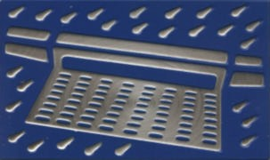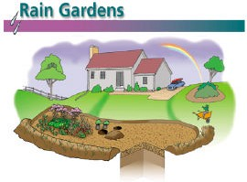
*For Further Information, Call the Galloway Township Department of Community Education at 652-9265
PROGRAM CO-SPONSORED BY GALLOWAY TOWNSHIP PUBLIC WORKS AND GALLOWAY COMMUNITY EDUCATION

