Is your dog green?

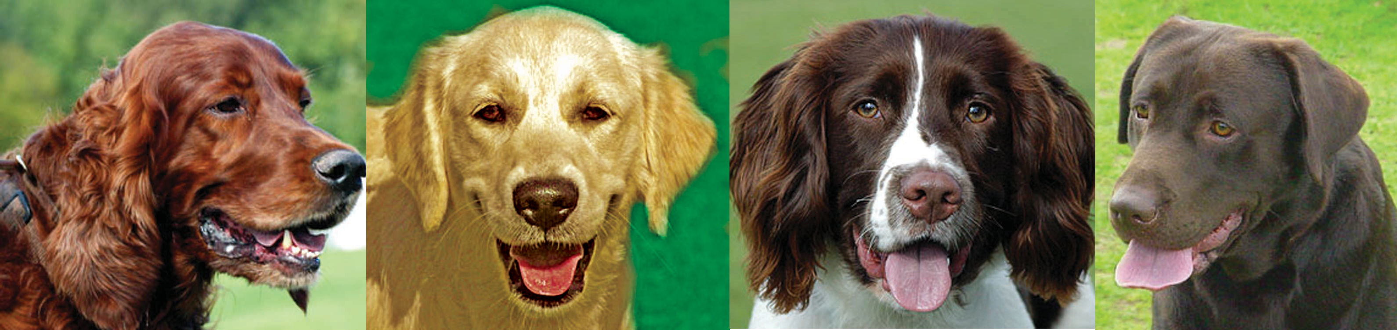
Copyright 2005 © copyright-free-pictures.org.uk. Used with permission

Storm drains can be found on streets throughout South BrunswickTownship.They collect rain water and prevent flooding when it rains. These drains empty directly into the nearest water body, usually a stream or river, without treatment of the water. This means that dog waste and other pollutants left on a lawn, on the street, or placed in storm drains, will get washed into our rivers and watersheds when rain falls. Our rivers and streams are areas of recreational swimming, boating and fishing and contribute to our drinking water sources.
Let’s remove dog waste from the
water pollution equation!
Scooping your pooch’s poop isn’t just a courtesy; it’s the healthy and environmentally sound thing to
do, AND it’s the law!
(Ordinance 2007-57) South Brunswick Code Section 14-49 requires all persons to immediately remove and appro-
priately dispose of animal feces from all public and private property. Penalties of up to $2,000 in fines, 90 days in jail and/or 90 days community service may be imposed for a failure to do so
Just one dog? A day’s waste from one large dog can contain 7.8 million fecal coliform bacteria.

Now, what you can do is on the reverse side.....

Here’s how to remove
dog waste from the water pollution equation:

BRING IT—Always bring a plastic bag when you walk your dog. So that you’re never without, carry grocery or newspaper bags in your purse, pocket or car.
BAG IT—Use the bag as a glove to pick up pet waste. Scoop up the waste and turn the bag inside out around the waste.
DISPOSE IT!—Properly dispose of pet waste by placing it in a trash can or flushing it, unbagged, down the toilet.
Protect our watersheds ... Do your part: Scoop the Poop!
What watershed? South Brunswick’s unique topology places it at the apex of two watersheds – the Stony Brook/Millstone Watershed and the Lawrence Brook Water- shed. These two watersheds contribute to the water supply of over two million people who reside in the Raritan River basin. All surface water runoff into these watersheds originates in South Brunswick and flows to Lawrence Brook in the northwest and to the Stony Brook-Millstone in the southeast. Any pollution is carried along with this flow into neighboring communities that depend on the waters of the Raritan River basin as a source of their potable water. These communities include New Brunswick and Milltown that draw water from Frarrington Lake and Franklin Township that is fed from the Mill- stone River.
Why is dog waste a problem? Scientific evidence has shown dog waste to be a signifi- cant source of water pollution because it contains a high concentration of nutrients as well as bacteria and disease-causing microorganisms.
- Your Health—Leaving pet waste on the ground may pose a risk to children and adults who can be exposed to to various diseases spread by feces.
- Your Water—Pet waste carries disease causing organisms such as giardia and salmo- nella, which can make water unsafe for drinking or swimming.
- Your Community—Swimming beaches and boating areas can be shut down due to bacterial contamination, of which pet waste can be the source.

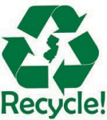
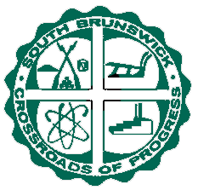
This project was made possible through the South Brunswick Township Stormwater Program and NJ Clean Community Program.

Printed on recycled and recyclable paper

