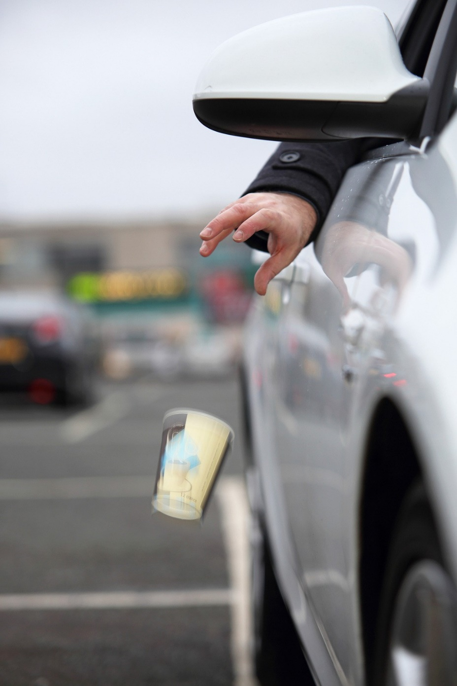
- What is litter?

- Why do people litter?

- Who and what can get hurt?

Litter is found along roads, in parks
and on school property.

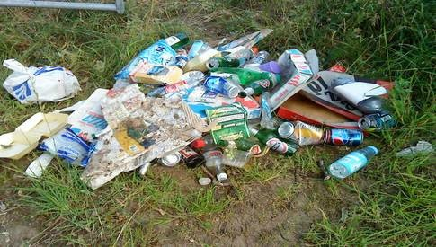

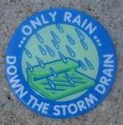
Storm Drains

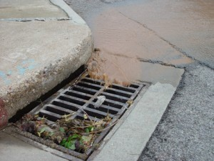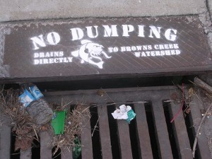

Storm drains lead to waterways!

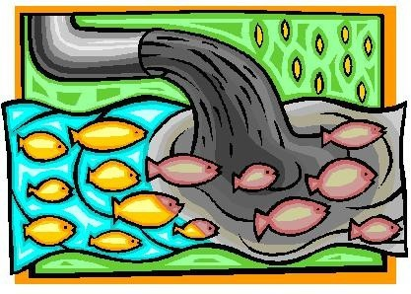

Is there a stream, river or pond
near your community?

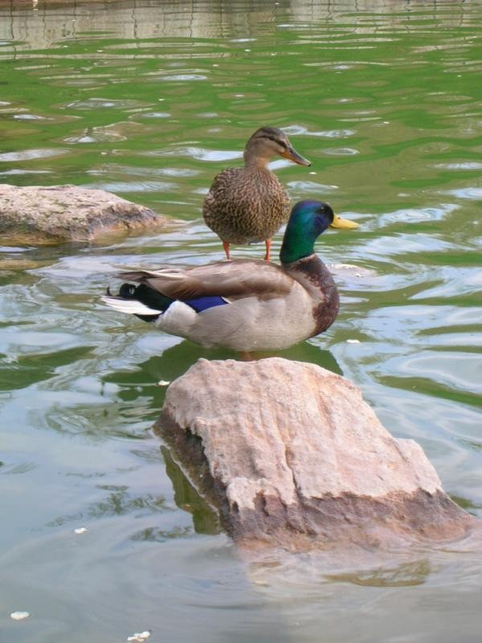

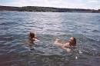

We love to spend time at the lake!

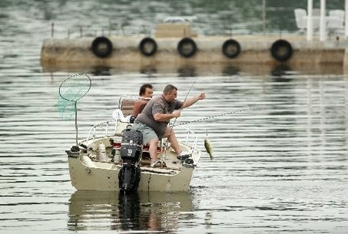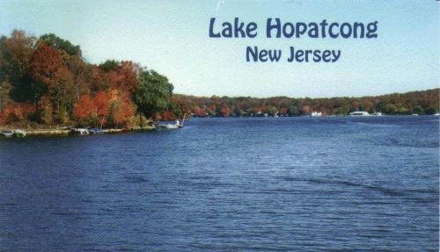
Let’s keep it clean and litter-free!

Do you have fun at the beach?

What will you do with your trash
when you are at the beach?

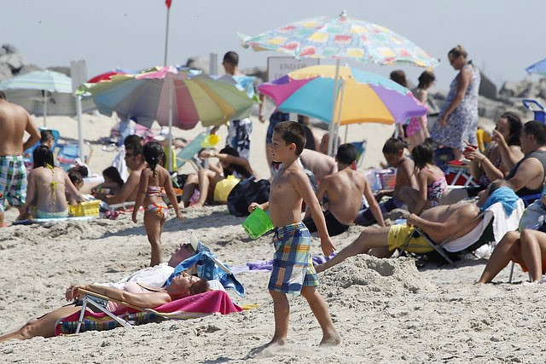
Sandy Hook Beach, July 2012

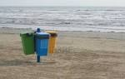
PLEASE use trash and recycling receptacles.
If not, carry your trash and recyclables home with you and dispose of them properly!

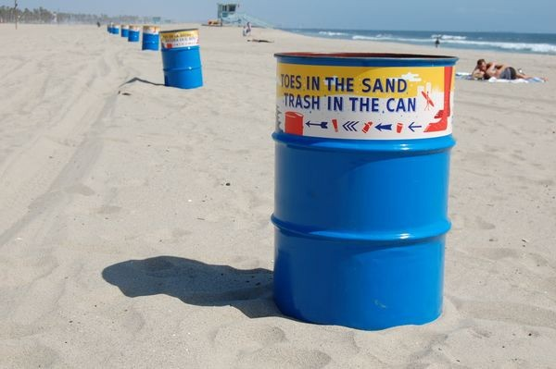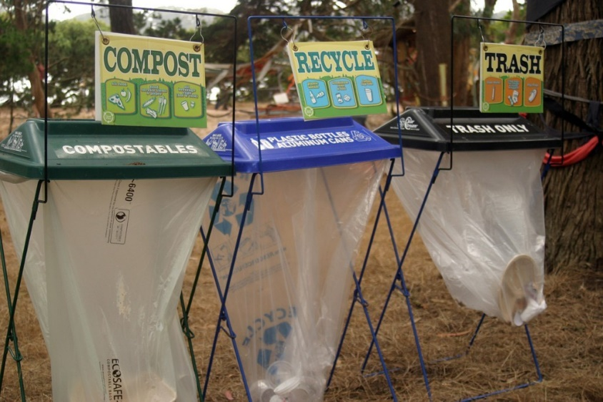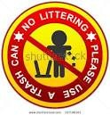

Litter is dangerous!

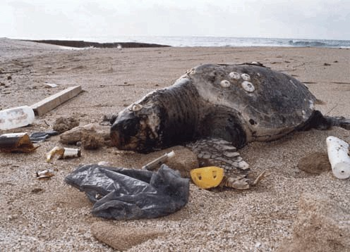

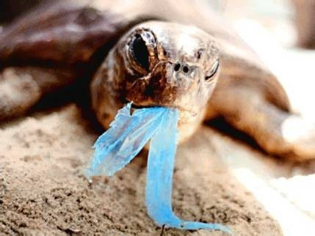

Animals mistake litter for food and try to eat it!

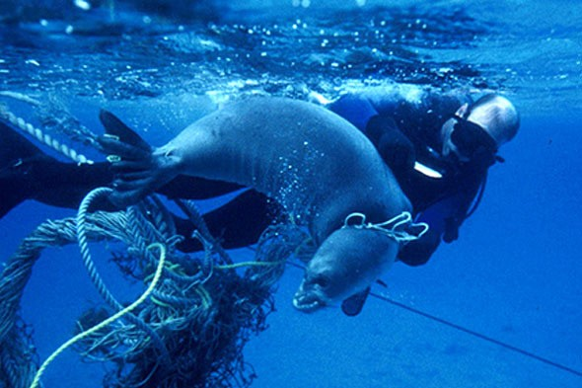

Discarded fishing nets and ropes are very dangerous!

Plastic six-pack holders entangle
animals.

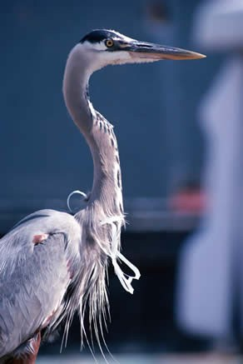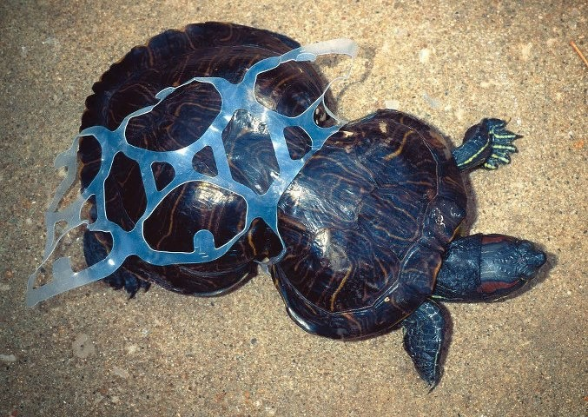

Plastic bags look like jellyfish, and some sea creatures eat the bags.

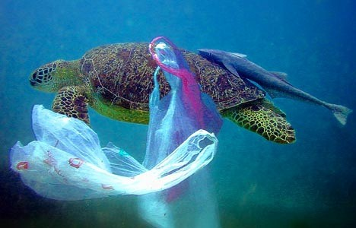

It’s in our hands.

Please do your part to reduce, reuse, recycle and respect our planet Earth!

Morris County Clean Communities

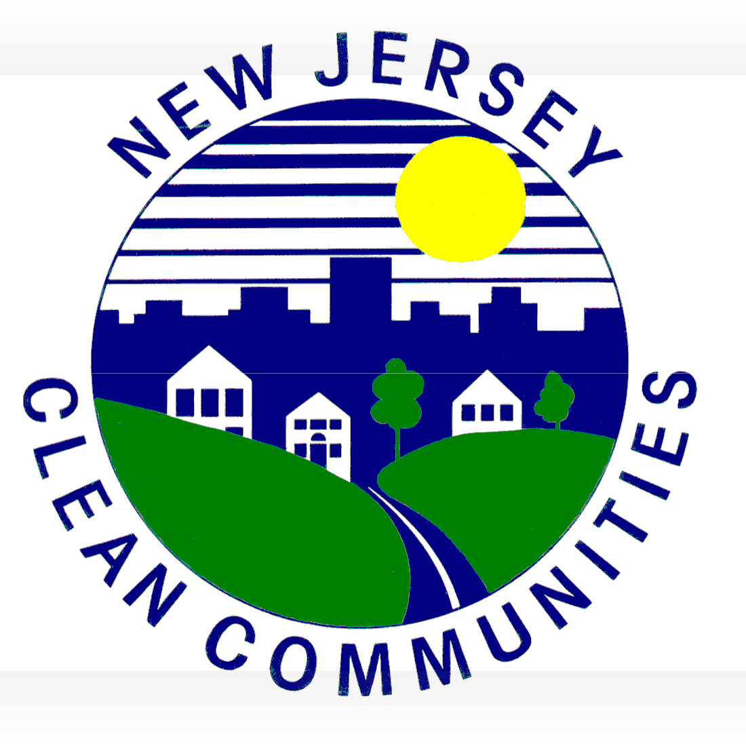
Campaign for a litter-free Morris County!
Thank you for NOT littering!

What is Household Hazardous
Waste (HHW)?

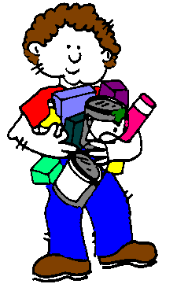

Examples of hazardous waste:
- Pesticides, herbicides and fertilizers
- Household cleaning products
- Oil-based paints and stains
- Paint thinners and solvents
- Motor oil, antifreeze, gasoline, kerosene transmission, steering and brake fluids
- Chemistry sets, mercury and mercury containing devices

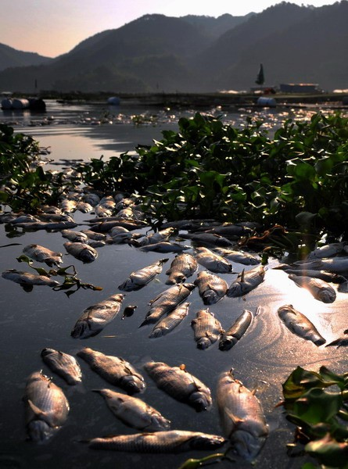
Fish die in polluted water!

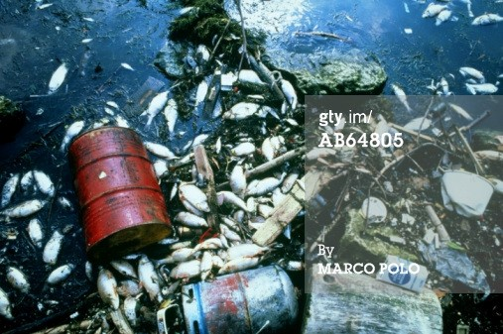

There are several causes of ocean pollution including oil pollution, marine debris, toxic materials, and ocean dumping.

Compact fluorescent bulbs

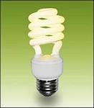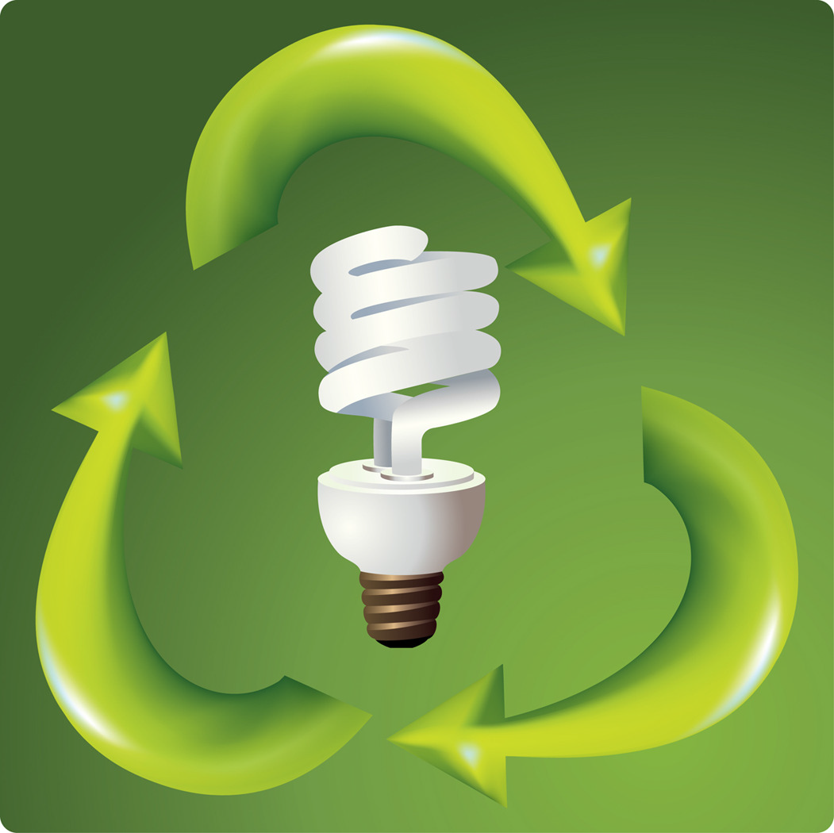
contain mercury!

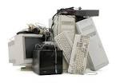
Electronics (E-waste)

  - Computers
  - Monitors
  - Printers, faxes, keyboards & peripherals
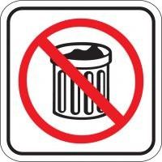
  - Scanners
  - Phones
  - Televisions

Don’t put electronics into the trash!

Be Responsible
Protect our Planet Earth

Be sure to dispose of household hazardous waste and electronics in a responsible manner.

Let’s do our part!

