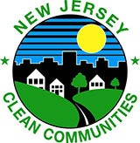
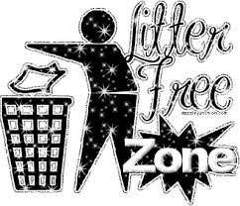

Clean Communities Pledge

I _________________________________________ (print your name)

promise to do my part to keep my community clean and litter free. I promise to keep my yard, school grounds, and my town clean and free of trash.

I will throw my trash into a receptacle in order to prevent litter, and I will pick up litter when I see it and dispose of it properly.

I will put all recyclables into the appropriate bin or receptacle. I will tell my family and friends how litter affects people, pets, animals and our Planet Earth!

Signature: __________________________
Date: _________________________

