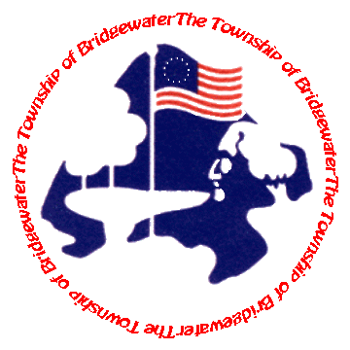
Bridgewater Township Clean Communities
100 Commons Way
Bridgewater, NJ 08807
Phone: 908-725-5750 Fax: 908-595-0825
MONDAY-THURSDAY 9AM to 5PM FRIDAY 8AM to 5PM

“SMART ART” Recyclable Art Contest Entry Form

The Bridgewater Township Environmental Commission and Creative Arts Committee are pleased to announce the first annual sustainable message or “SMART ART” contest for intermediate and middle school-aged students. Multiple prizes will be awarded for original artwork constructed of recyclable materials, items that have the potential to become litter, or contains a recycling or litter control theme. All submitted pieces will be placed on display at the Township Eco-Blast Fair on May 2, 2015. Winning pieces of art will be determined by a panel of judges, recognized at the event, and placed on display at the Bridgewater Municipal Complex. All entries to be judged on the criteria of creativity and innovation.

Submission Guidelines:
- Contest is open to intermediate and middle school-aged residents.
- All eligible artwork must be composed of recyclable materials or items that have the potential to become litter or contain a materials recycling or litter control theme.
- Artwork must weigh no more than 15 pounds.
- Piece must be 100% original in concept, design and execution and may include sculpture, painting, drawing, collage, prints, mixed media, computer generated art & photography.
- Two-dimensional pieces must be pre-mounted and/or hang-able. All pieces must have the artist’s name on it (either on front or back).
- Artist must submit completed entry form along with artwork.
- Prizes to include 2 winners for each grade level ($100), 2 “People’s Choice Awards” ($100) and one Grand Prize ($200).
SUBMISSION DUE DATE: April 24, 2015
BRIDGEWATER DEPARTMENT OF HUMAN SERVICES
100 COMMONS WAY BRIDGEWATER, NJ 08807
Name:_______________________________________________________________________________________________
Grade:____________________ | School:_____________________________________________________
Address:_____________________________________________________________________________________________
Phone:_______________________________________________________________________________________________
E-mail:_______________________________________________________________________________________________
I, ______________________________________________, give permission for Bridgewater Township to display my work at the Municipal Complex.
Signature: of Parent or Guardian___________________________________________________________________
The Township retains the right to deny entry of artwork that may depict or contain inappropriate language or content. Awards available through a grant from New Jersey Clean Communities.

Contest Entries – 2015

