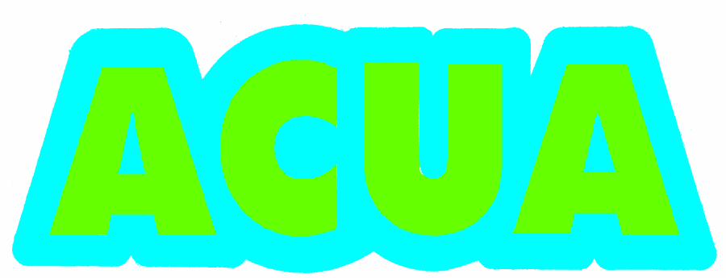
Mini-Grant Program

Mini-Grants will be offered to all Atlantic County Adopt A Road groups, businesses and individuals who fit the required criteria:

- Participating groups and individuals with a 1-mile or more stretch of county road or bike path must perform at least 4 cleanups a year on both sides of the entire mile (or more) of road. Participating groups and individuals with less than a mile stretch of county road or bike path must perform at least 6 cleanups a year on both sides of the adopted stretch or road.

- One member of each group must fill out a Summary Report immediately after every cleanup. This Report must be submitted to the Clean Communities Coordinator within 2 days of the cleanup. You will only get credit for cleanups that were reported in a timely manner. It is your responsibility to follow up with the Clean Communities Coordinator to make sure that these reports are being received.

- There is no minimum number of people who must participate in the cleanup but there must be a ratio of at least 1 adult per every 5 children participating. All children under 18 must have a written permission slip signed by a parent or guardian on file with the Clean Communities Coordinator.

- No children under the age of 11 are permitted to participate in a road cleanup at any time. Special permission may be granted for a group with younger participants to participate in cleanups on the Atlantic County Bike Path, Adopt A Schoolyard locations, or other locations deemed safe by the Clean Communities Coordinator.

- Participants must adhere to all of the established Adopt A Road Guidelines and Safety Precautions at all times.

- Every group/individual must appoint one contact person and keep the Clean Communities Coordinator up to date with current contact information. If this person leaves the group or decides to no longer participate in the program, another member must takeover and new contact information must be immediately provided.

- The required 4 cleanups must be spread out evenly between March-May (ie. all 4 cleanups can not be done in March and April just to meet the deadline). The goal is to keep the road adequately clean throughout the year.

- If all of the criteria have been met, you or your group will receive a mini-grant for $200. This $200 is per group only, not per road adopted. New groups or individuals adopting roads close to the mini-grant application deadline will be not be eligible for that year’s mini-grant and will have to wait until the following year to apply.

- The deadline for the completion of all required cleanups and the submission of required application and paperwork is April 22, 2022

If interested or would like more information,
please call Rebecca Turygan at (609) 272-6962.

***The requirements for mini-grants are subject to be changed at any time ***
at the Clean Communities Coordinator’s discretion.

Adopt-A-Road
Mini-Grant Application

Name of Group (if applicable):

Contact Person:

Mailing Address:

Telephone Number:

Email:

I, ______________________________________ the group leader representing

________________________________________________ , have read, understood, and
(group name)

fulfilled the following Adopt-A-Road Mini-Grant requirements:

► Have completed the required amount of cleanups a year (on both sides of the road) based upon the
length of road that myself or my group has adopted
► Have submitted cleanup Summary Reports in a timely manner after every cleanup
► Have followed all Adopt-A-Road safety guidelines

Signature _______________________________

Date ____________

The application must be received by
Mail or Fax this application to:
Rebecca Turygan
P.O. Box 996
Pleasantville, NJ 08232
rturygan@acua.com
Fax: 609-872-1242

