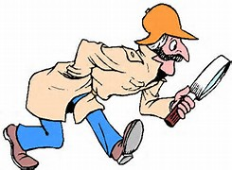 Trash Hunt (Cumberland County)

Each year in the early spring, Cumberland County holds a “Trash Hunt”. This event is coordinated with the Cumberland County Sportsman’s Federation, which is made up of hunting clubs, fishing groups, ATV rider organizations. The County also works closely with NJDEP Fish and Game officers.

The Authority provides hunter orange hats, gloves, trash bags, and container service for the event. All tipping fees at the landfill are also waved by the County for the event.

Participating volunteers “hunt” for trash in the public lands and bring it back to designated collection sites. Efforts are made to recycle tires, metal, batteries, and clean wood waste.

The Trash Hunt is a great way to involve groups who may not have thought about volunteering for litter cleanups!

