Litter
in America
Results from the nation’s largest litter study

Key Findings: CIGARETTE BUTT litter

Cigarette butts are the most frequently littered item. Tobacco products comprise 38% of all U.S. roadway litter and 30% at “transition points,” places where smokers much discontinue smoking before proceeding. As part of Keep America Beautiful’s 2009 Littering Behavior in America* research, specific data was gathered about cigarette butt lit- tering. This included observations of smokers at recreation areas, bars/restaurants, retail, and medical/hospitals.

The overall littering rate for cigarette butts is 65%.

This is slightly higher than the 58% rate found in the general littering observations.

- When a cigarette butt is littered, dropping with intent is the most frequent behavior or strategy (35%), followed by “flick/fling” (27%), and “stomp” (27%).

- Most cigarette butts are littered on the ground (85%), 37% into bushes/shrubbery, 25% on or around trash recep- tacles, and 15% into planters.

Cigarette butt littering is more influenced by the environment than general littering. One of the strongest predictors of cigarette butt littering is the number of ash receptacles.

- 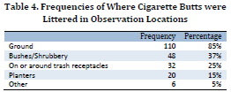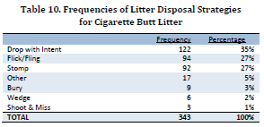38% of cigarette butt littering is associated with the physical environment, including the number of ash receptacles. The presence of ash receptacles, either as

stand-alone, or integrated into a trash can, correlates with lower rates of cigarette butt littering.

- For every additional ash receptacle, the littering rate for cigarette butts decreases by 9%.

- At the time of improper disposal, litterers were an average of 31 feet from an ash receptacle. While trash receptacles are widespread (at 91% of observed sites), ash receptacles are less common, with only 47% of ob- served sites having an ash only or ash/trash receptacle.

- Of smokers who work, 41.8% report that they do not have receptacles for cigarette butts at their work location.

More on reverse side...

* The 2009 National Visible Litter Survey and Litter Cost Study was prepared by MidAtlantic Solid Waste Consultants for Keep America Beautiful, Inc. Research reports and an executive summary can be downloaded at www.kab.org/research09. Keep America Beautiful, Inc. 2009 national litter and littering behavior research were conducted through a grant from Philip Mor-
ris USA, an Altria Company. Wm. Wrigley Jr. Company Foundation sponsored the creation of these fact sheets. All contents Copyright 2010 Keep America Beautiful, Inc. – www.kab.org. January 2010

Litter
in America Results from the nation’s largest litter study

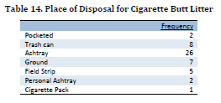Another strong predictor of cigarette butt littering is the amount of existing litter.

  - Smokers are more likely to litter if the environment contains any type of litter, not just cigarette butts. More littered environments encourage more littering.

  - Medical/hospital sites have the highest littering rates, followed by recreation areas, bars/restaurants, and then retail locations and city centers.

63% of cigarette butt littering is attributable to individual motivations.

    - Younger adult smokers are more likely to litter cigarette butts than older smokers, although there is no correlation with gender.

    - Only 14% of current smokers report owning a pocket ashtray, and 28.1% report that they do not have a receptacle for cigarette butts in their car.

    - 77% of individuals in an intercept survey report that they thought cigarette butts were litter. When asked how they disposed of their cigarette butts when outside, most report using an ashtray. Others report using a trash can or dropping the butt to the ground.

These key research findings indicate that that the most effective ways to address cigarette butt littering include increasing the availability of ash receptacles and portable ashtrays, decreasing the amount of existing litter through clean-up activities, and educating the public with motiva- tional messages that target individual responsibility and obligation.

Copyright 2010 Keep America Beautiful, Inc. – www.kab.org. January 2010

