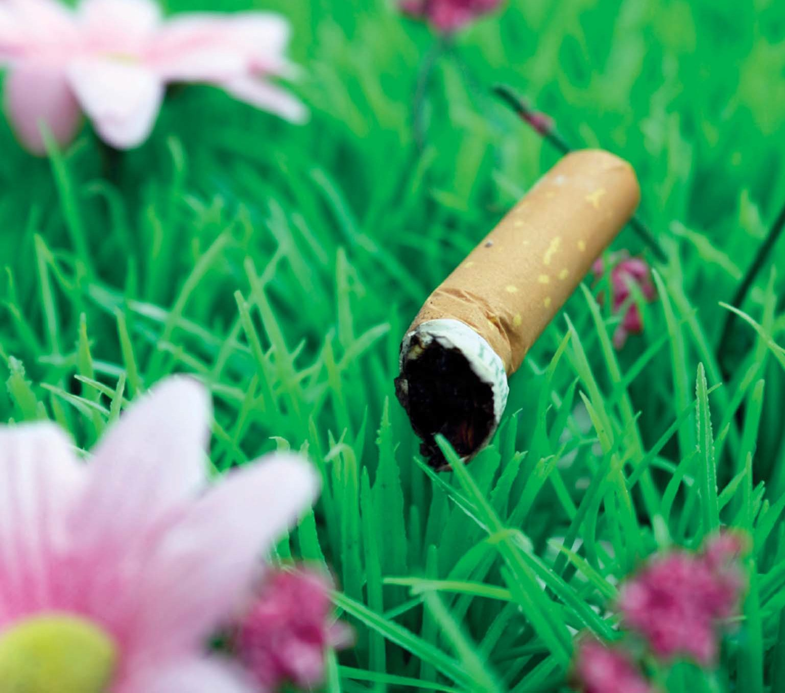
THIS IS LITTER TOO.

PROTECT OUR PARK.
DON’T LITTER.
DISPOSE OF CIGARETTE BUTTS PROPERLY.

