## FLASHCAM - PROACTIVELY PROTECT YOUR COMMUNITY FROM NUISANCE CRIMES.

Don't let nuisance crimes such as **METAL THEFT**, **ILLEGAL DUMPING, GRAFFITI** and other unwanted activities destroy your community! These crimes are contributing to the decay of public parks, railways, schools and even taking down power for an entire city. Not only are these crimes a "nuisance" they are costly to repair and reverse the damages.  
  
The **FlashCAM** is a portable, solar-charged, motion-activated crime fighting tool used by cities & counties across the country to help protect their community from these types of nuisance crimes. The unique deterrent features, such as the loud customizable voice warning and bright flash, STOPS criminals in their tracks. The system also captures high resolution images that can be used to identify vandals and vehicles, including license plate numbers up to **250 feet in TOTAL DARKNESS.**

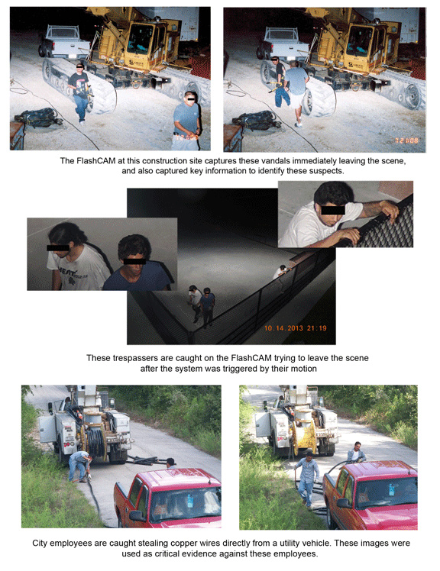  
**For more information or to schedule a FlashCAM demonstration, contact us toll-free at 877.783.0774 or email us at** [**FightCrime@qstartech.com**](mailto:FightCrime@qstartech.com)