**How about a robot or mascot to promote your message?**

*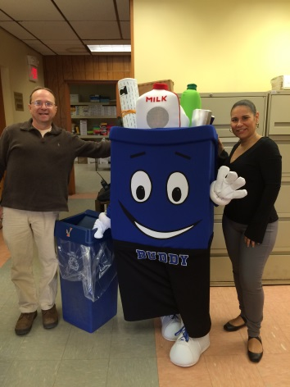Recycling Buddy mascot*

*Perth Amboy*

Facemakers Inc.

800 Chicago Avenue

Savanna, IL 61074

815-273-3944

www.facemakersincorporated.com

*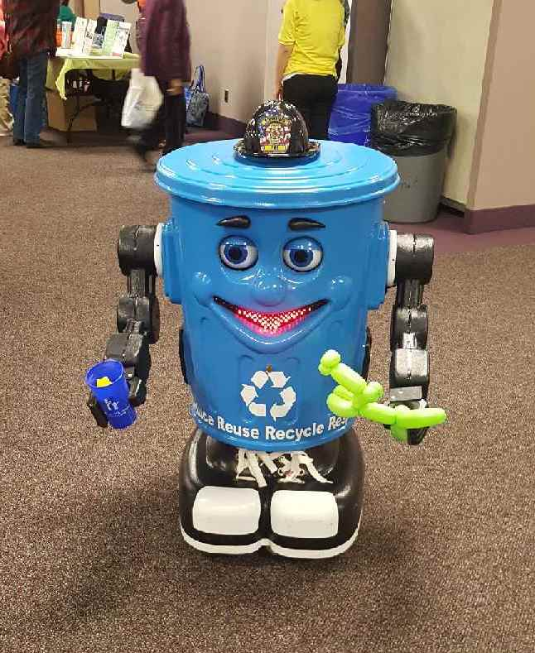Toms River Robot*

ROBOTRONICS

1610 West 1600 South

Springville,UT 84663

1-800-762-6876

[www.robotronics.com](http://www.robotronics.com)

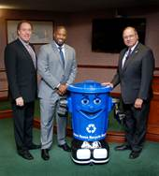

*Curby the Recycling Robot*

*Union County*

Also from Robotronics