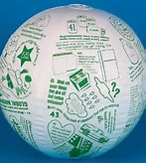
Go Green Toss’n Talk About Ball

The is a useful tool when doing presentations. Toss the ball and the person that catches it must ask the question under his or her right thumb.
http://www.ssww.com/item/green-toss-talk-about-ball-17118/?ga_list=product+recommendation+%3A+product+page

