How Long Does it Take to Decompose?

Make your own game! Bergen County made a game based upon how long it takes various items to decompose in the environment. Sayreville followed with their version. It’s a great way to interact with residents at public events.

See page two for information on decomposition times.

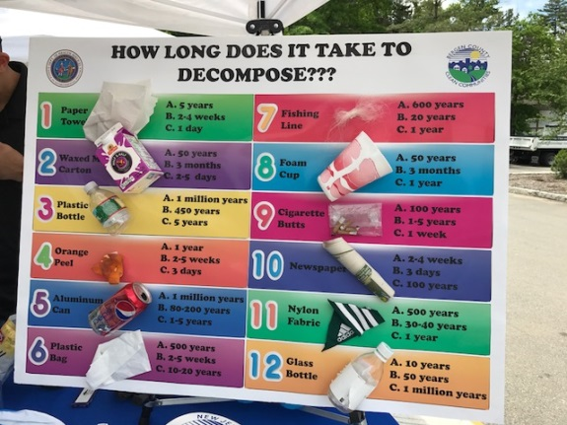

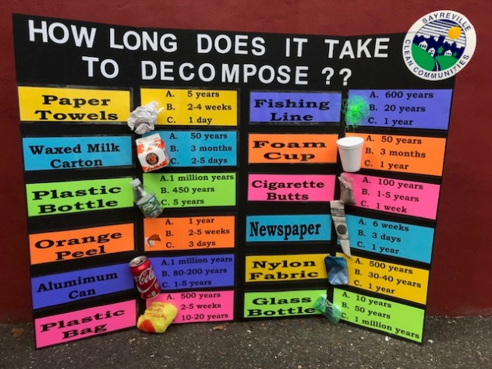

From <http://www.des.nh.gov/organization/divisions/water/wmb/coastal/trash/documents/marine_debris.pdf>

