**Litter Pledge Websites**

[www.njclean.org/i-pledge.html](http://www.njclean.org/i-pledge.html)

Slam Dunk the Junk

Help the New Jersey Clean Communities Council send the message of “clean and green” to all New Jerseyans. Join our online team of people who have committed to “Slam Dunk the Junk”. Click on the button below to sign the “Slam Dunk the Junk” support petition.

Other litter pledge websites:

[www.earthsaversclubforkids.com/kidspledges.aspx](http://www.earthsaversclubforkids.com/kidspledges.aspx)

[www.nomoretrash.org/](http://www.nomoretrash.org/)

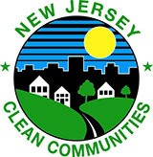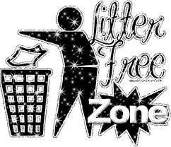

**Clean Communities Pledge**

I _________________________________________ (print your name)

promise to do my part to keep my community clean and litter free. I promise to keep my yard, school grounds, and my town clean and free of trash.

**I will throw my trash into a receptacle in order to prevent litter**, **and I will pick up litter when I see it and dispose of it properly**.

I will put all recyclables into the appropriate bin or receptacle. I will tell my family and friends how litter affects people, pets, animals and our Planet Earth!

Signature: __________________________

Date: __________________

