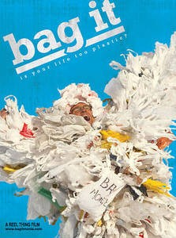

BAG IT

The Movie “Bag It” takes a close look at how plastic bags are used and misused and end up harming our planet Earth.

Talking points:

- Waste, Litter and Recycling
- Ocean health and marine debris
- Bag politics
- Single-use disposables
- Human health
- Ocean health

THE BAG IT CURRICULUM

Watching Bag It is the first step toward creating change; our curriculum will enable your students to delve deeper into the issues and inspire them to act. Developed by educators Laura L. Kudo, M.A., and Amy Laubenstein, Ed. M., our curriculum allows students to explore the effects of their everyday behavior on the environment, their health and their well-being.

The lessons included in Bag It's curricular guide are geared toward students in grades 4-12 and correlate with the chapters within Bag It's Educational DVD: Single-Use Disposables; Waste and Recycling; Oceans; Human Health; and Activism. Each chapter has one or two lessons and within each lesson there are several interactive and hands-on activities.

To purchase the “Bag It” Educational DVD, visit New Day Films. Also available at Amazon.

www.bagitmovie.com

Use Bag It in your classroom with Making Movies That Matter, a hands-on program created by Mountainfilm in Telluride to get middle and high school students involved in multi-media projects using documentary films. A screening of the film Bag It is followed by guided, hands-on, digital editing projects in which students use footage from the source film to craft their own short video reactions to themes and issues raised.

The program emphasizes 21st century skills—critical thinking, visual literacy, creativity, and technology – and provides meaningful content for Media Arts classes as well as for Language Arts, Social Studies and Science classes.

Guidelines for teachers and digital footage for student projects are now available. For more information, please contact ellen@mountainfilm.org.

