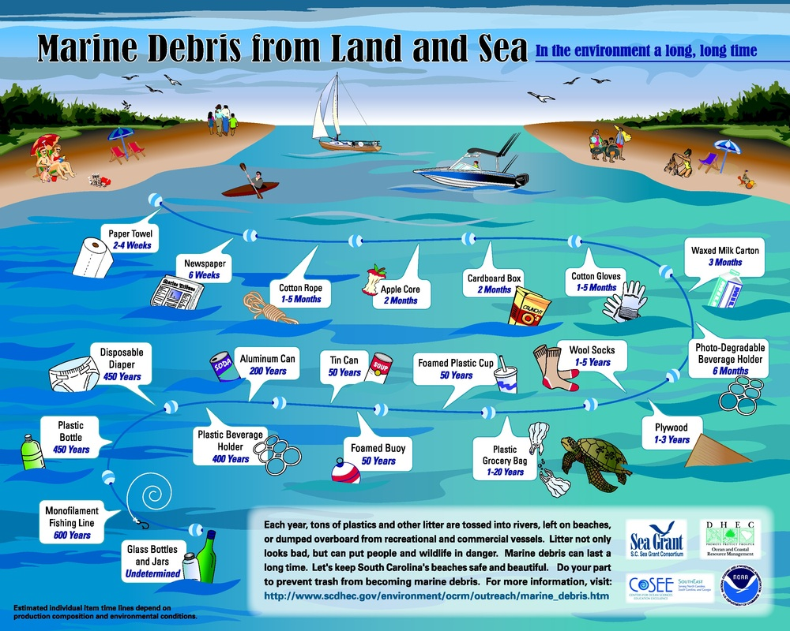

[](http://www.google.com/url?sa=i&rct=j&q=&esrc=s&source=images&cd=&cad=rja&uact=8&ved=0ahUKEwjx69CKkaDMAhVCPz4KHRjrDaUQjRwIBw&url=http://7428.net/tag/beach&psig=AFQjCNH2A3zQ6k9sRrTwRszvIuo8DkznrQ&ust=1461341902114603)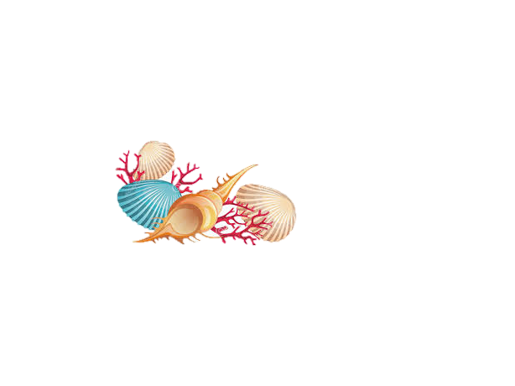[](http://www.google.com/url?sa=i&rct=j&q=&esrc=s&source=images&cd=&cad=rja&uact=8&ved=0ahUKEwjx69CKkaDMAhVCPz4KHRjrDaUQjRwIBw&url=http://7428.net/tag/beach&psig=AFQjCNH2A3zQ6k9sRrTwRszvIuo8DkznrQ&ust=1461341902114603)