PROTECT OUR WATERWAYS

CITY OF CLIFTON
PUBLIC/PRIVATE LANDS CLEAN/SWEEP-UP MONTH
(Sept. 30th-Oct. 30th)

Watershed Protection - Clifton Girl Scouts troop #41 Alerting the Public about non-point source pollution.

Girl Scouts Troop #46 volunteer to clean and improve our Public Park Lands.
W245354-01
CLIFTON DEPT OF PUBLIC WORKS Mon, Aug 21, 2006
4 cols, 7.71 x 10.00"
Process
Robert Iantosca SPEC
Paul

OK AS IS

As part of an ongoing commitment to environmental stewardship and protection of our Public Lands, the City's Clean Communities Committee, and Mayor and Council will partner with New Jersey Clean Communities Urban Cleanup
OK W. CHANGE
Team, the National Public Lands and Take Pride in America Programs to announce Sept 30th- Oct. 30th as
"Take Pride in Clifton-Clean/Sweep-up-Month"

Residents, businesses, civic groups and schools will volunteer their time and talents to clean/sweep their properties along with a myriad of public properties throughout the City. Several groups are already committed to participate in removing litter, recycling, planting trees, flowers and shrubs, and preserving streams, ponds and nature trails.
If your organization would like to participate and you know of a neglected public land,
please contact adubois@cliftonnj.org- 973-470-2239. Also visit Clifton's web site at www.cliftonnj.org

To learn more about these organizations please contact:
National Public Lands Day- www.publiclandsday.org- 1-800Vol-TEER (865-8337) Take Pride in America- www.TakePride.gov - 202-208-5848
N.J. Clean Communities Urban Clean Program- www.njclean.org - 1-609-989-5900
approved by

Botany Village-cleanup and renewal of public neighborhood land through organizations, citizens, and business.
W245354-01
Public Land transformed, beautified and paid for by Schweighardt Florist-Family. The Island is now maintained by Clifton Discount Vacuum.

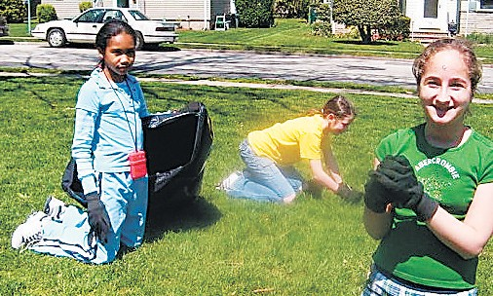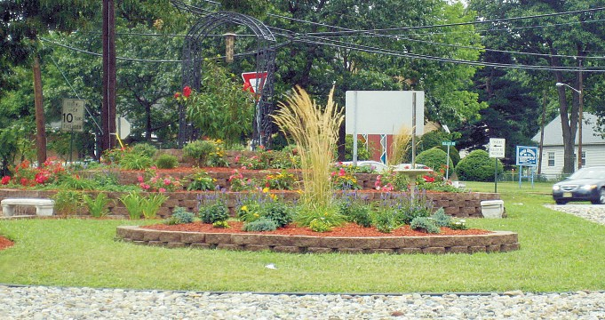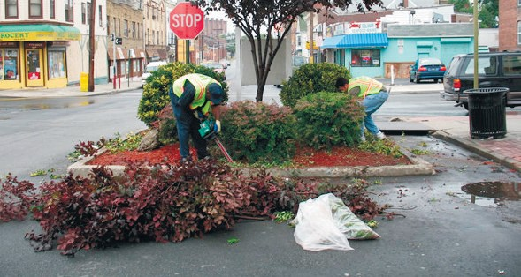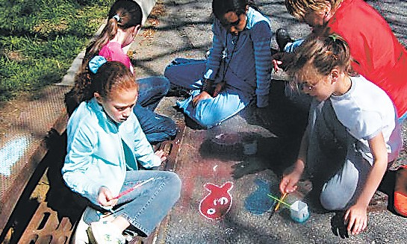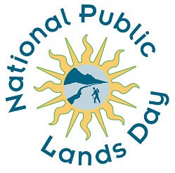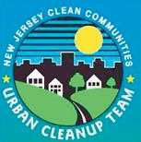
Take Pride in Clifton • Keep It Clean and Green!!!
For more information contact: adubois@cliftonnj.org or visit www.cliftonnj.org

PRESERVE OUR PUBLIC LANDS

